CSIT 128 PROJECT:

A Comprehensive Report on the First Deliverable

Amine Qabil (8050910) – Mohamed Yasser Kamel (7757463) – Ansaf Sabu (7390440) – Yasin Sheikh (8140352)

University of Wollongong in dubai

Table of Contens

1 Introduction 3

1.1 Problem Statement 3

1.2 Description 3

2 User Interface Flow 4

3 Required Web-Pages 5

3.1 Login Page 5

3.1.1 HTML FILE 5

3.1.2 CSS 8

3.2 Sign-up Page 10

3.2.1 HTML 11

3.2.2 CSS 11

3.3 Home page 12

3.3.1 HTML 14

3.3.2 CSS 15

3.4 Contact Page 16

3.4.1 HTML 17

3.4.2 CSS 18

3.5 About Page 19

3.5.1 HTML 19

3.5.2 CSS 20

3.6 Profile Page 21

3.6.1 HTML 22

3.6.2 CSS 23

3.7 Services. 24

3.7.1 HTML 25

3.7.2 CSS 26

3.8 Service Form 27

3.8.1 HTML 28

3.8.2 CSS 29

3.8.3 JSON Object 30

3.8.4 JavaScript File 33

4 Resources Used: 33

Figure 1: User Interface Flow Diagram 4

Figure 2: Screen Capture of the Login Screen 5

Figure 3: HTML Code of the Navbar in the Login Page 5

Figure 4: HTML Code of the Left-Side Container in the Login Page 6

Figure 5: HTML Code for the Login Container 7

Figure 6: CSS Code for Most Webpages 9

Figure 7: The Sign Up Page 10

Figure 8: HTML Code for the sign in form 11

Figure 9: Home Page 14

Figure 10: Partial HTML Code 14

Figure 11: CSS Sample Code for Home Page 15

Figure 12: Contact Page 16

Figure 13: HTML Code of the Contact Form 17

Figure 14: Partial CSS Code for Contact 18

Figure 15: About Us Page 19

Figure 16: HTML Code for About Us Page 19

Figure 17: CSS Code for the About page 20

Figure 18: HTML Code for the profile page 22

Figure 19: Sample CSS Code of the profile page 23

Figure 20: The Service Page 24

Figure 21: Simple HTML Code for the Service page 25

Figure 22: CSS Sample Code for Service Page 26

Figure 23: Service-form Page 27

Figure 24: Sample HTML Code 28

Figure 25: Partial CSS Code for the service-form page 29

Figure 26: JSON Object 32

Figure 27: JavaScript Code 33

# Introduction

## Problem Statement

Patients are inconvenienced and frustrated by the current healthcare system's lack of an effective and user-friendly platform for scheduling medical appointments. The current procedure involves manual phone calls, lengthy wait times, and restricted information access, which causes medical care to be delayed and lowers patient satisfaction. It is urgently necessary to develop a website that provides easy-to-use appointment booking services, enabling patients to quickly make appointments with medical specialists while also giving them thorough details on the specialties, availability of doctors. The objective is to close the communication gap between patients and healthcare professionals, improving the quality of care overall and providing prompt access to medical services.

## Description

The suggested website is intended to transform the process of scheduling doctor's appointments by giving patients a seamless and user-friendly platform to do so. It provides a wide range of features to improve the patient’s experience in general. The website's main attributes are listed below:

Users can register for accounts on the website and manage their profiles by entering the required personal and medical data.

Appointment Scheduling: Through the internet, patients may quickly schedule appointments with the services they like. They can choose a time that is convenient for the appointment and get a prompt confirmation. By ensuring real-time synchronization with doctors' schedules, the system minimizes scheduling conflicts and avoids double reservations.

Feedback System: Through the Contact Us page, patients can give comments and ratings regarding their encounters.

The website's overall goals are to make scheduling appointments with doctors easier, offer detailed information on healthcare providers, and improve patient happiness by streamlining the healthcare process.

# User Interface Flow

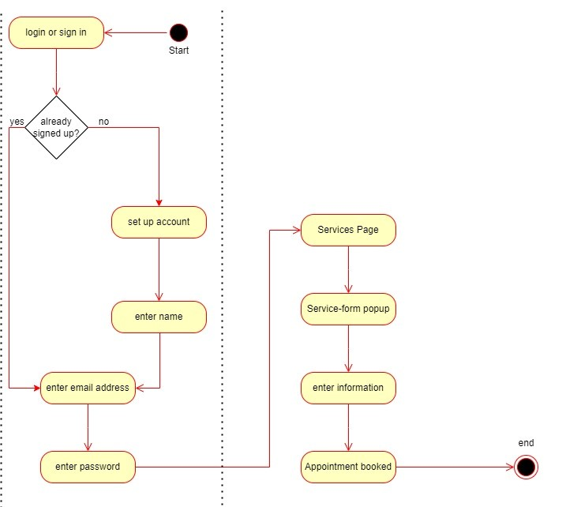

Figure 1: User Interface Flow Diagram

# Required Web-Pages

## Login Page

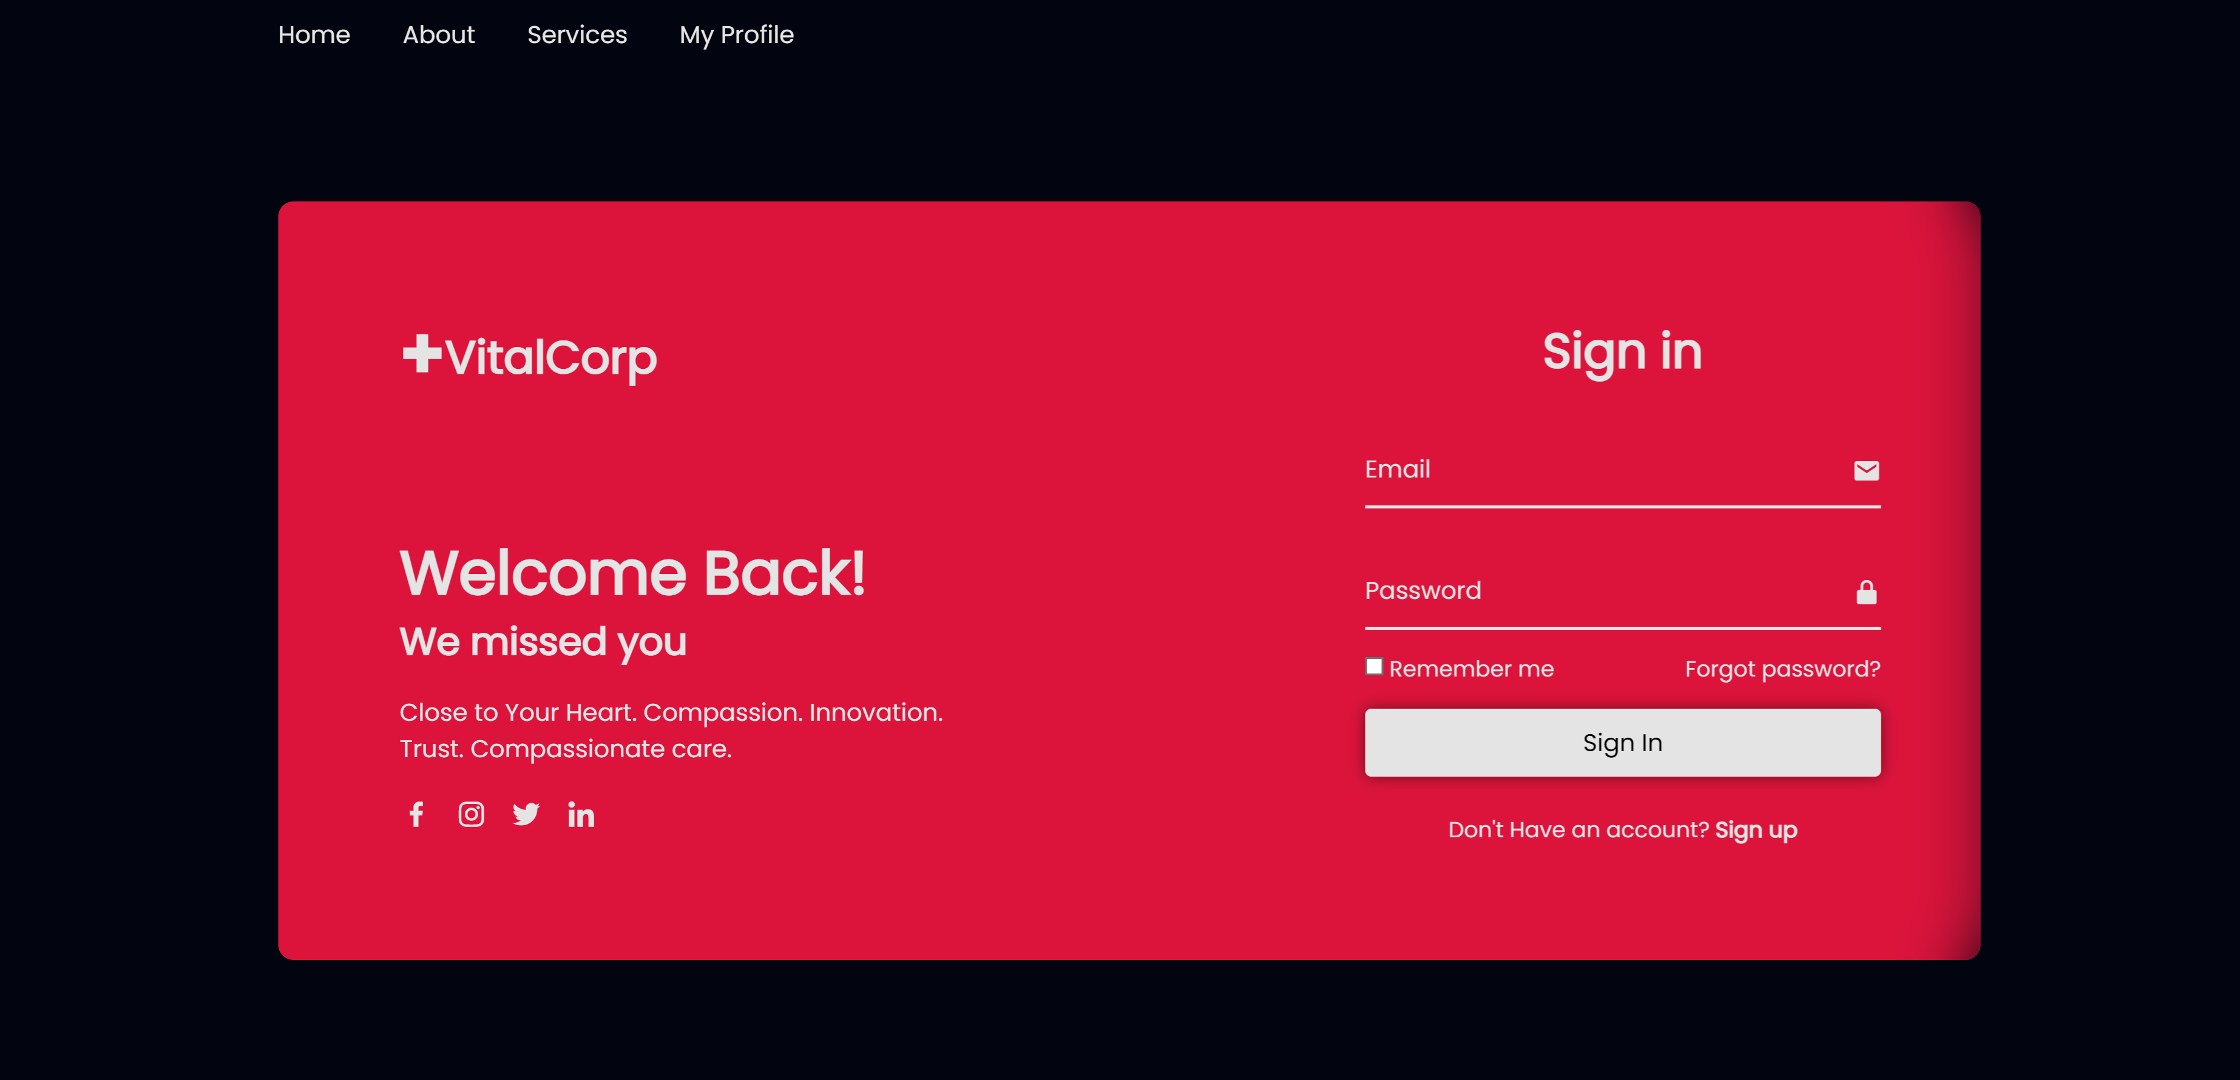

Figure 2: Screen Capture of the Login Screen

### HTML FILE

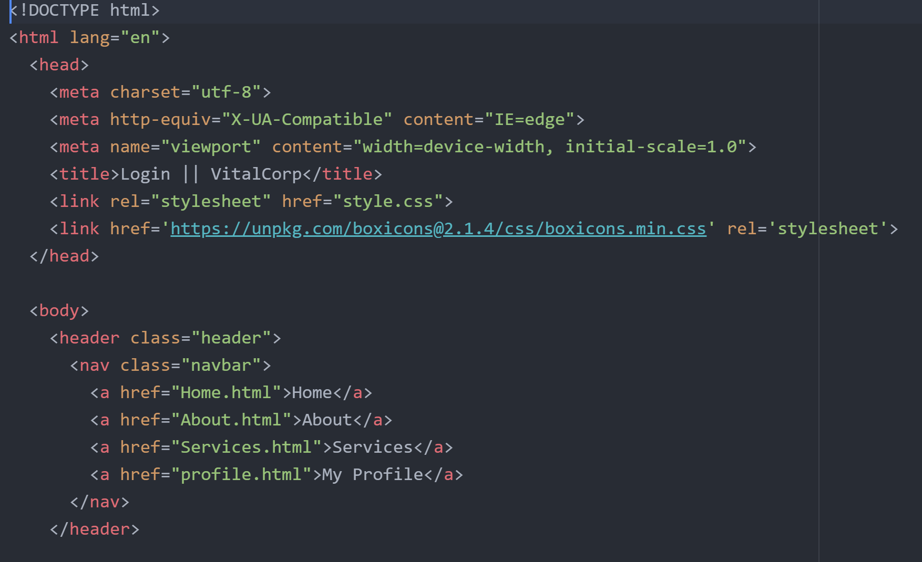

Figure 3: HTML Code of the Navbar in the Login Page

We’re starting off the page by creating a navigation bar inside the header, with links that will redirect the users to the other webpages. This piece of code will be reused throughout most webpages.

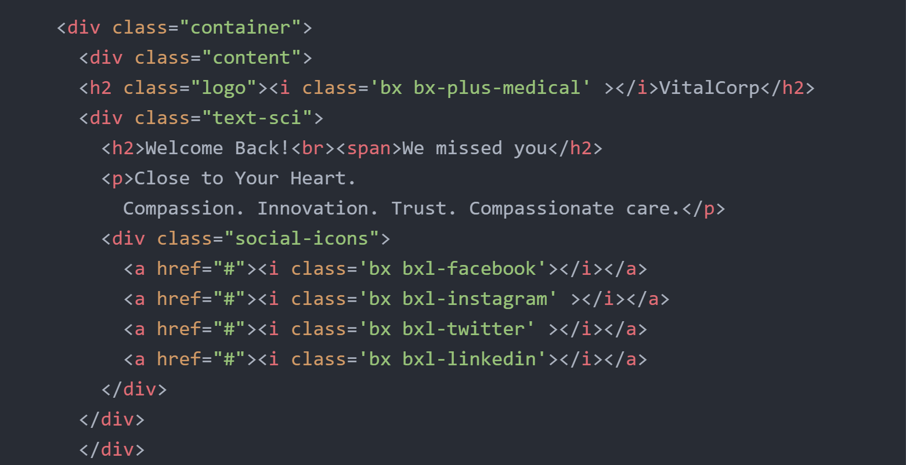

Figure 4: HTML Code of the Left-Side Container in the Login Page

For aesthetic purpose, it was decided for the login page to be divided into two containers, one containing social links and some text, and the other one containing the login form.

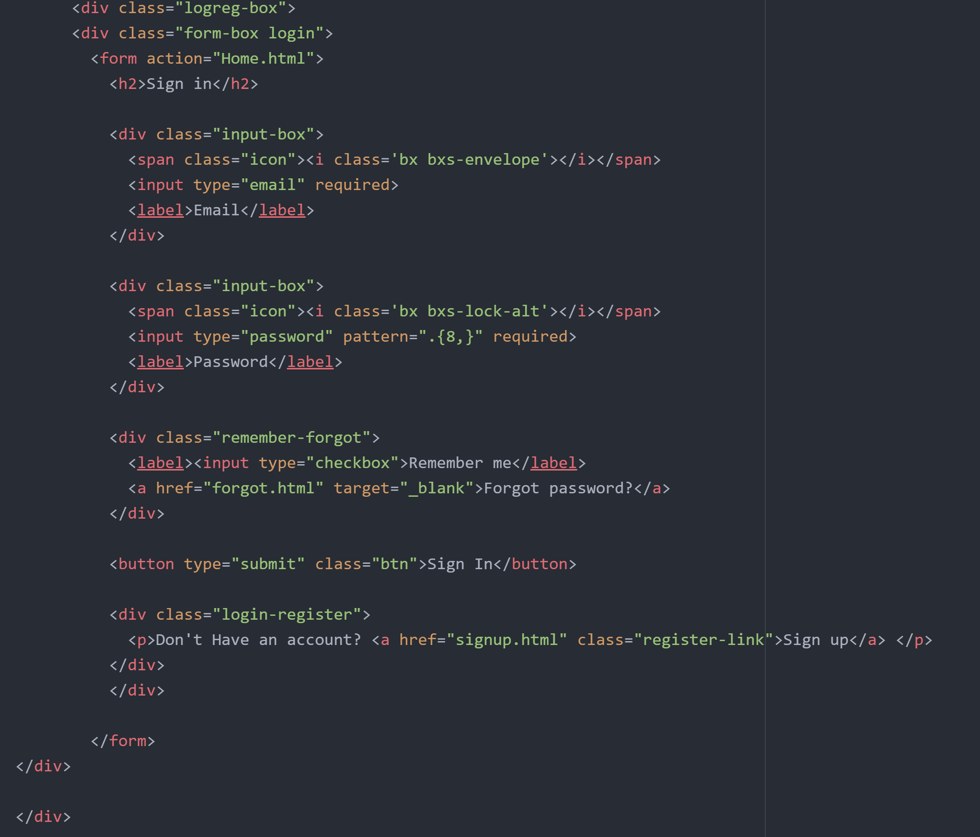

Figure 5: HTML Code for the Login Container

A simple form with each input inside a div class, with the necessary form validation.

### CSS

The Following are some screenshots for the Cascading Style Sheet, these will be used for all the webpages: 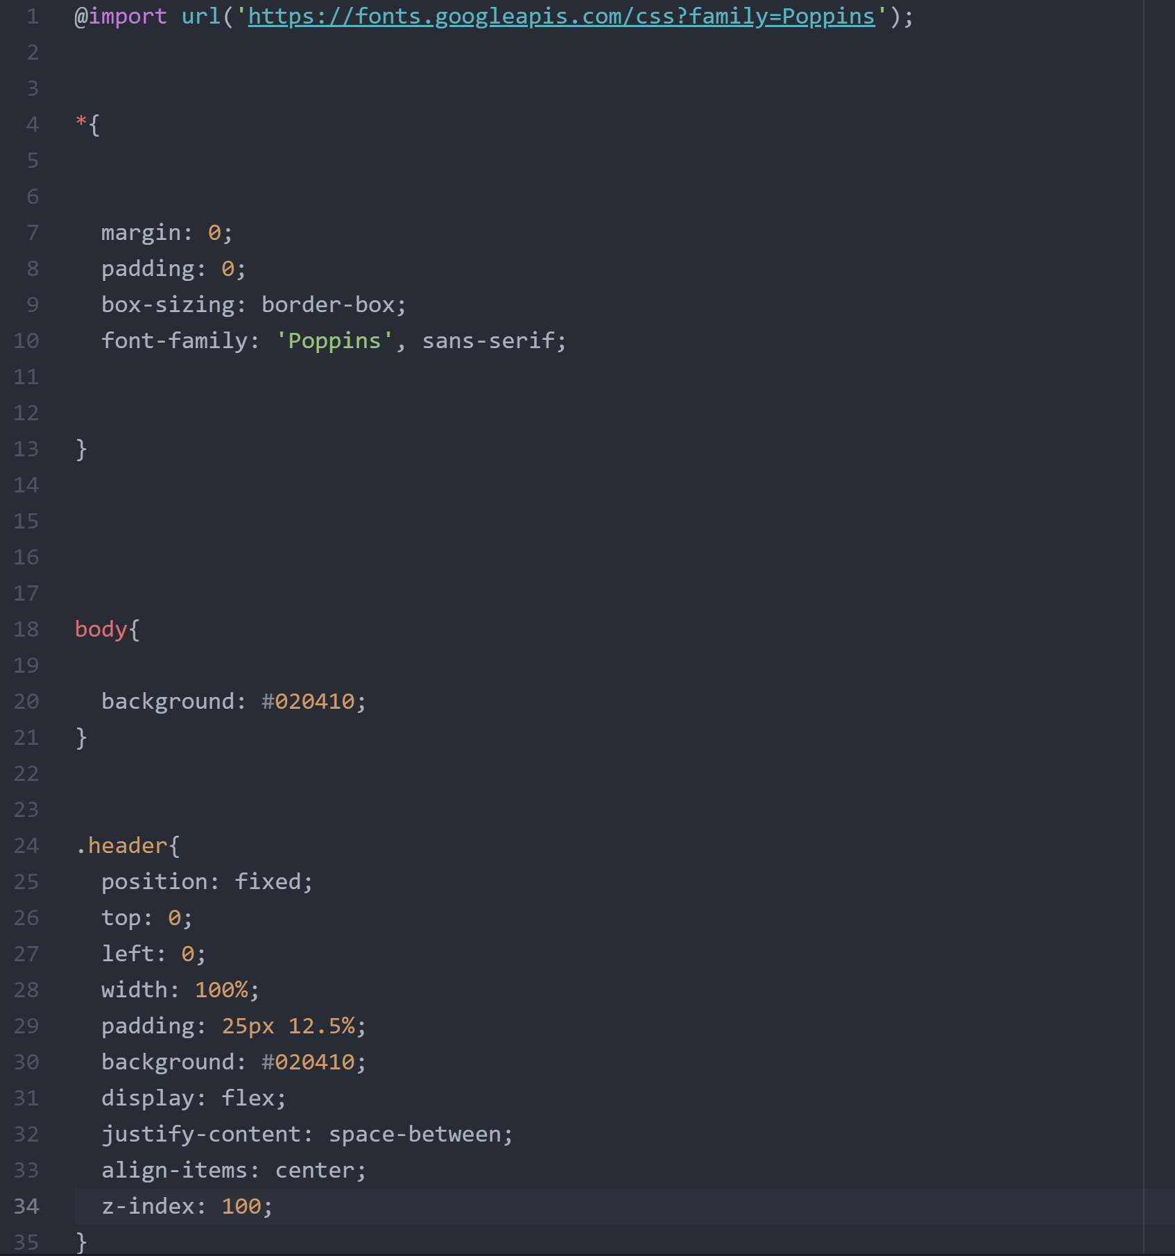

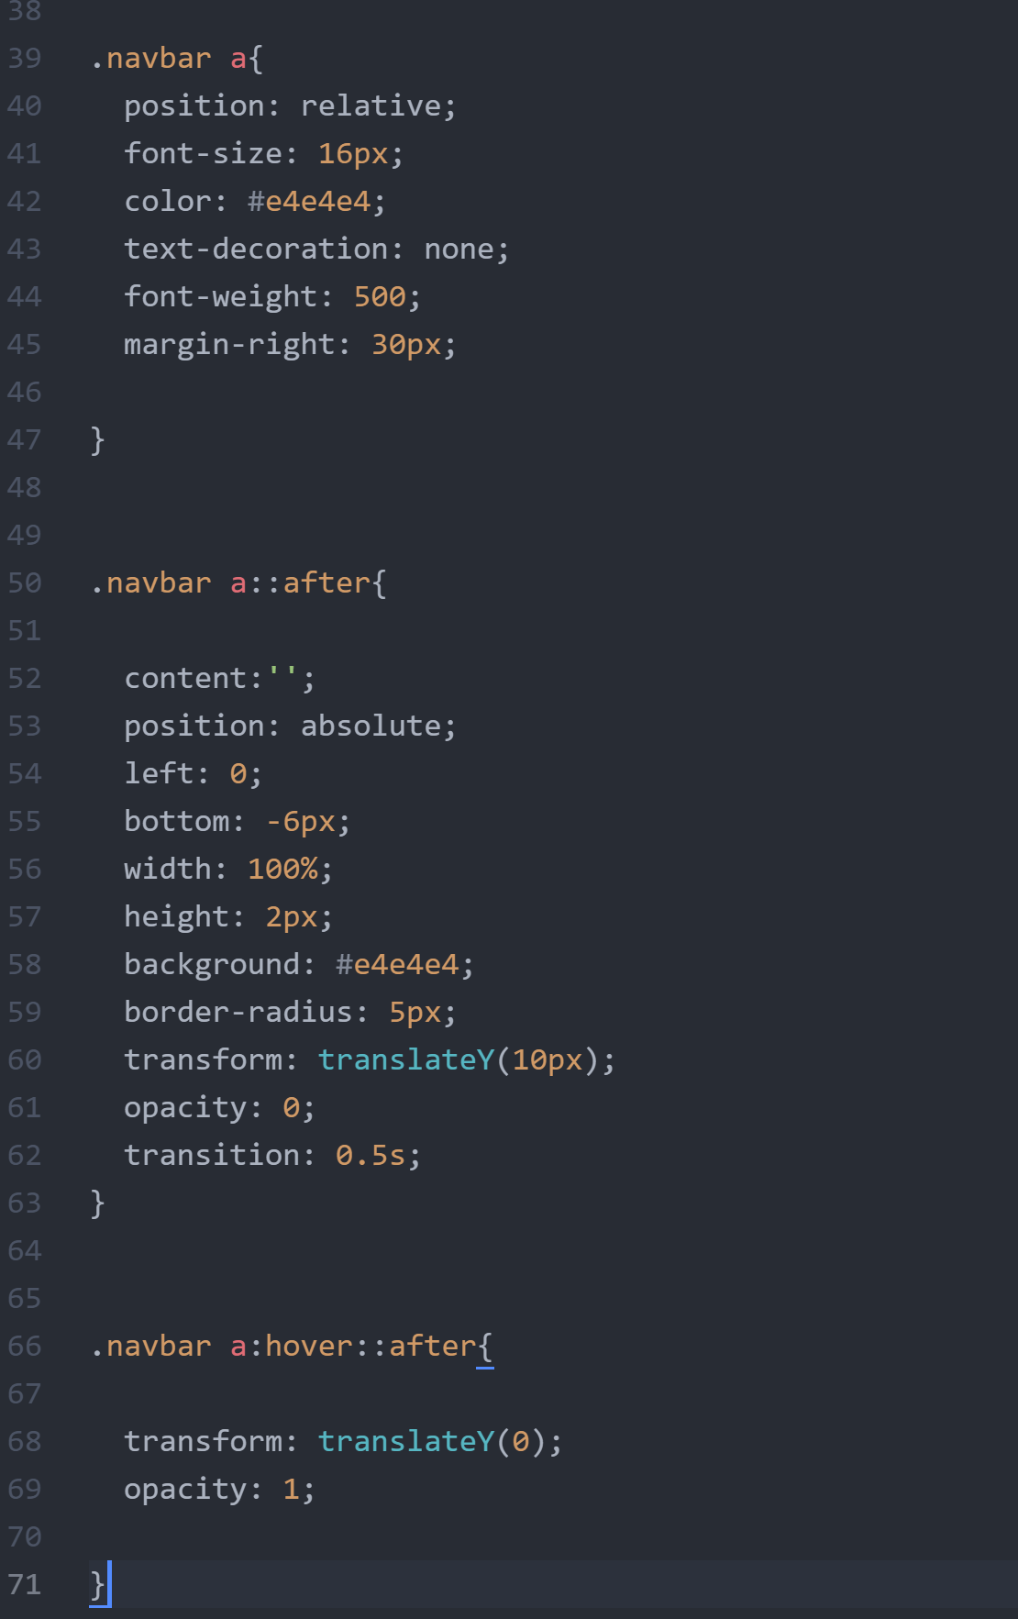

Figure 6: CSS Code for Most Webpages

## Sign-up Page

This page is accessible through clicking the “sign up” link in the Login page.

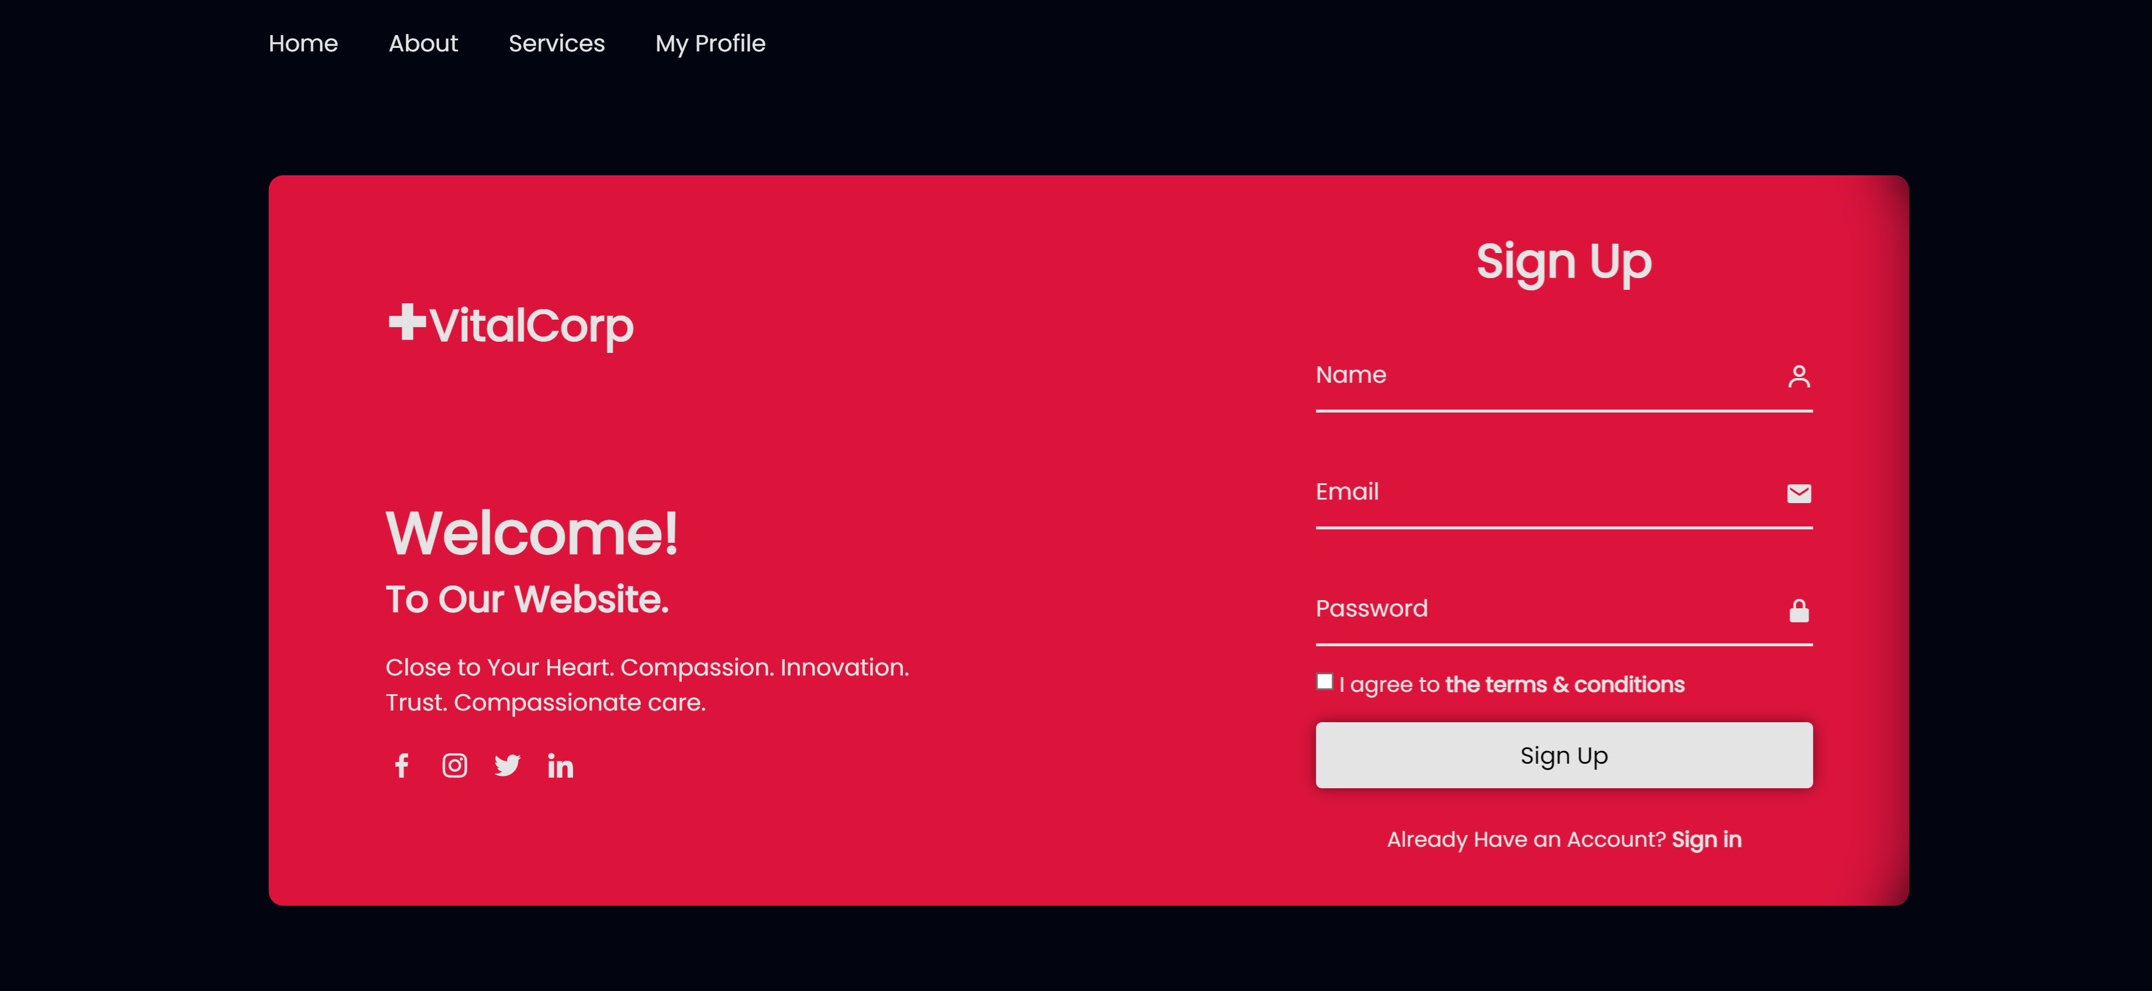

Figure 7: The Sign Up Page

### HTML

The HTML code is similar to the login page, with the added text input for the name and the checkbox for the terms and conditions. 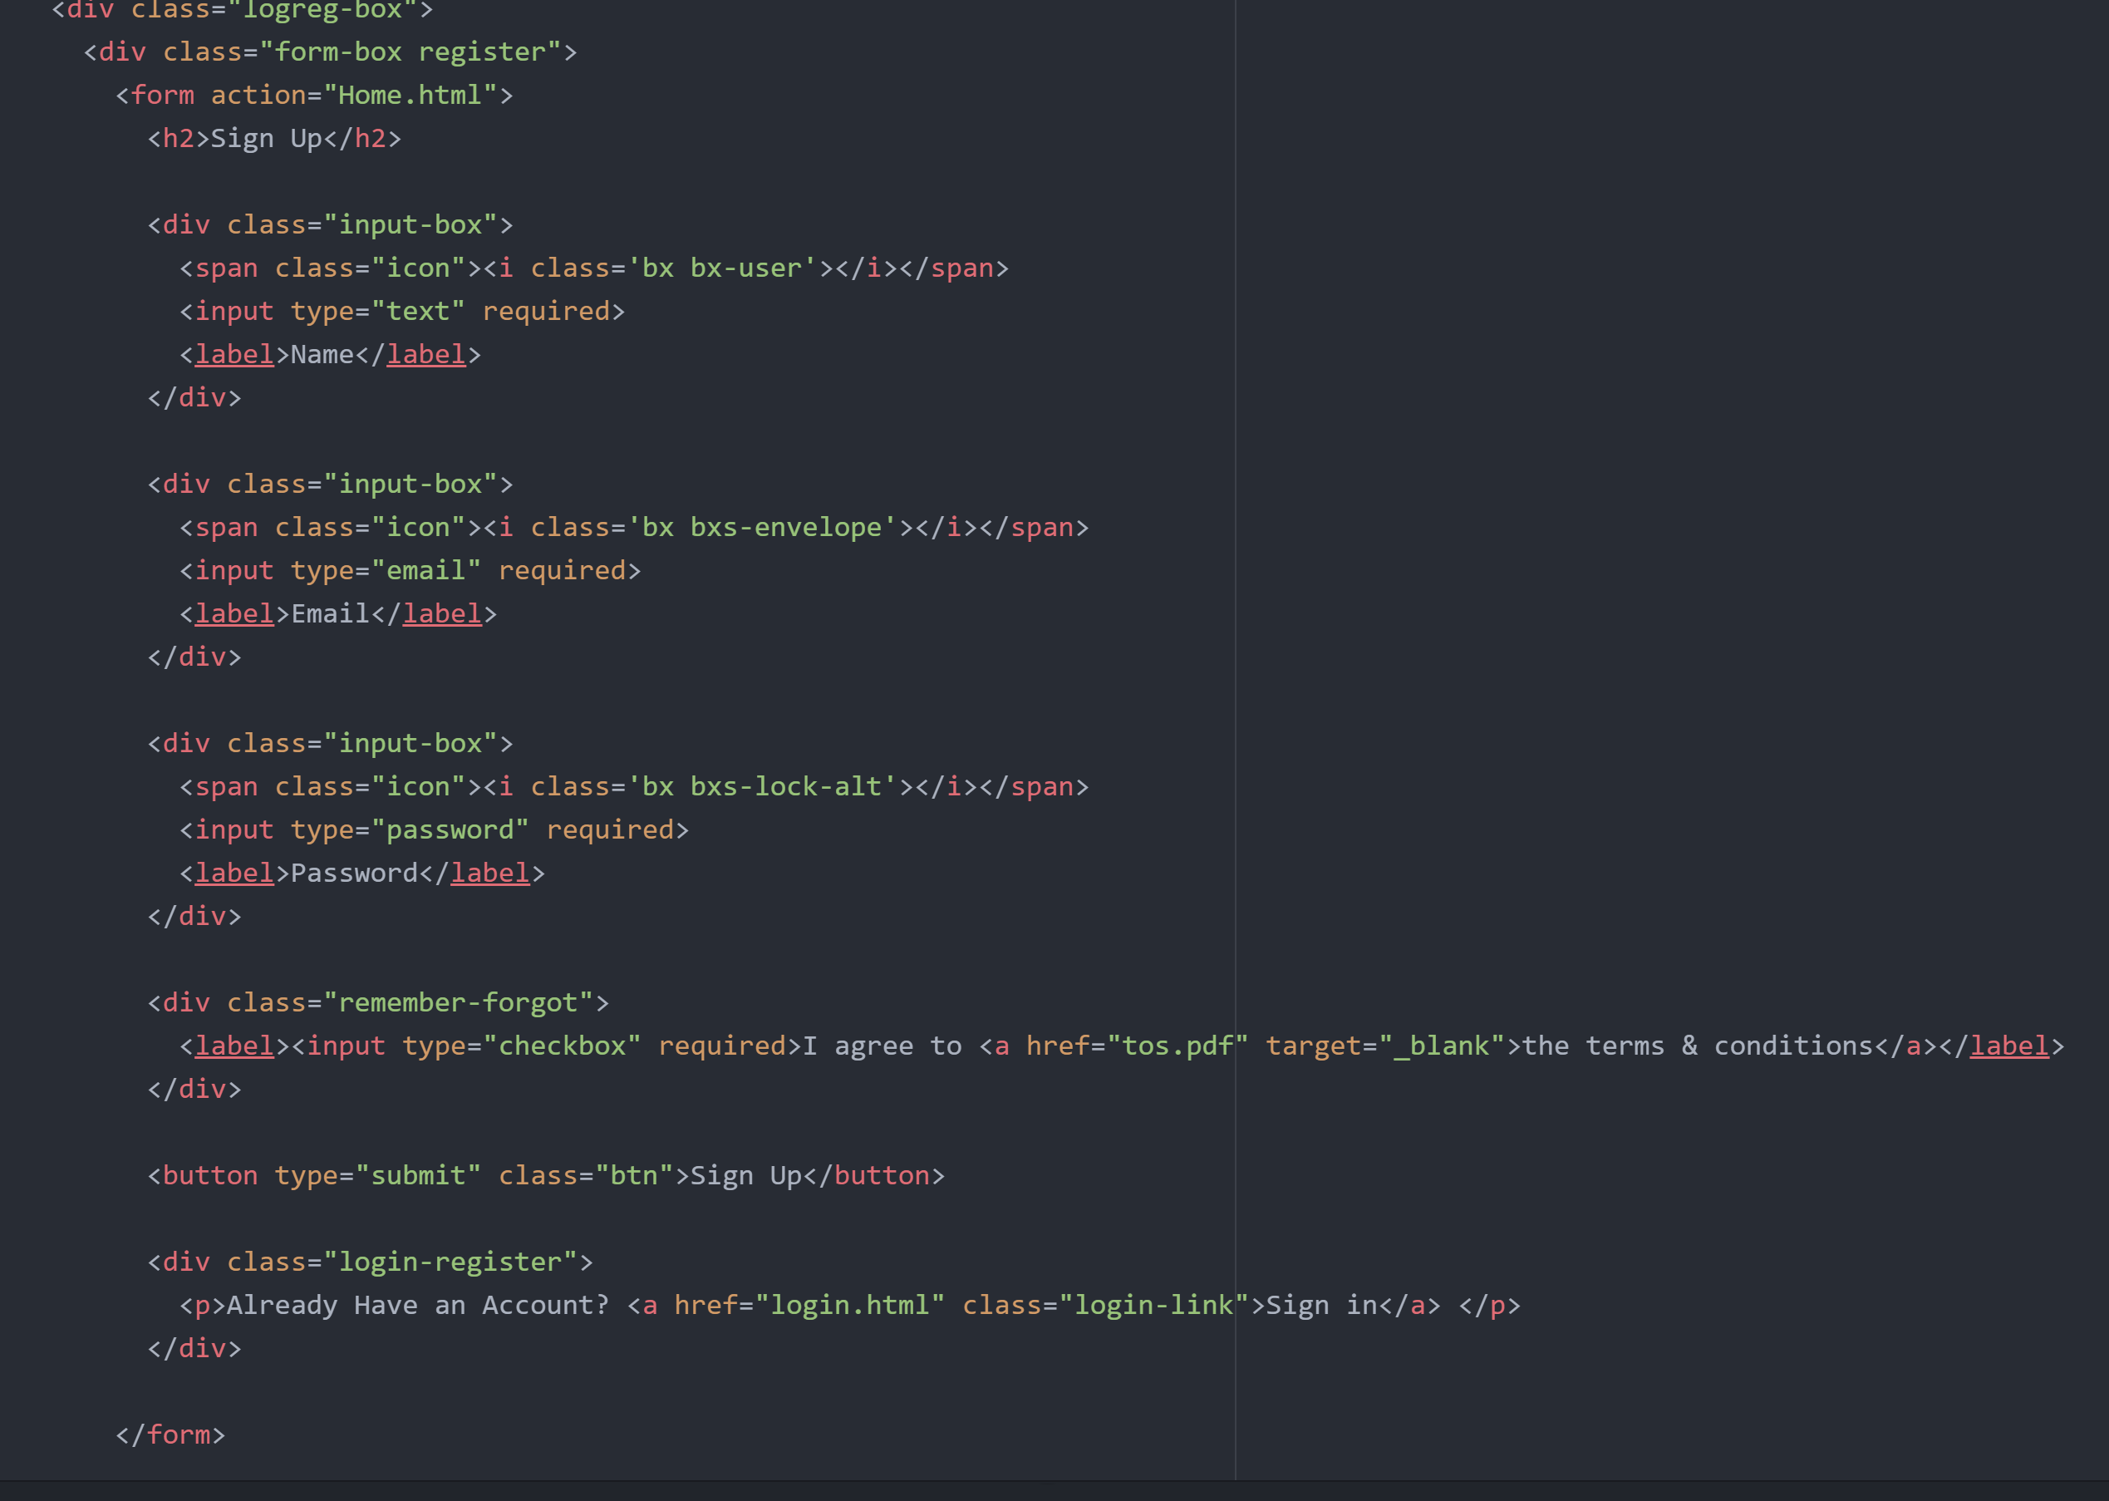

Figure 8: HTML Code for the sign in form

### CSS

The CSS file is similar to the login one.

## Home page

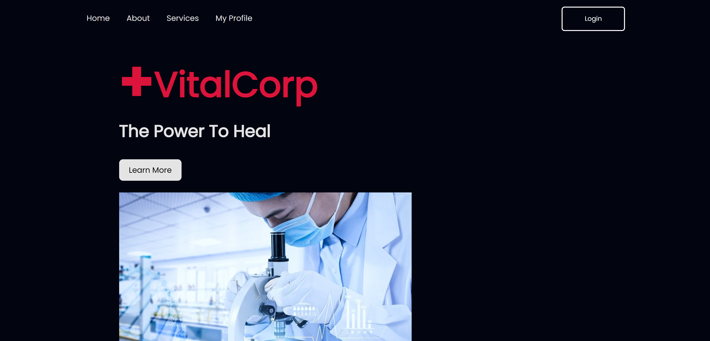

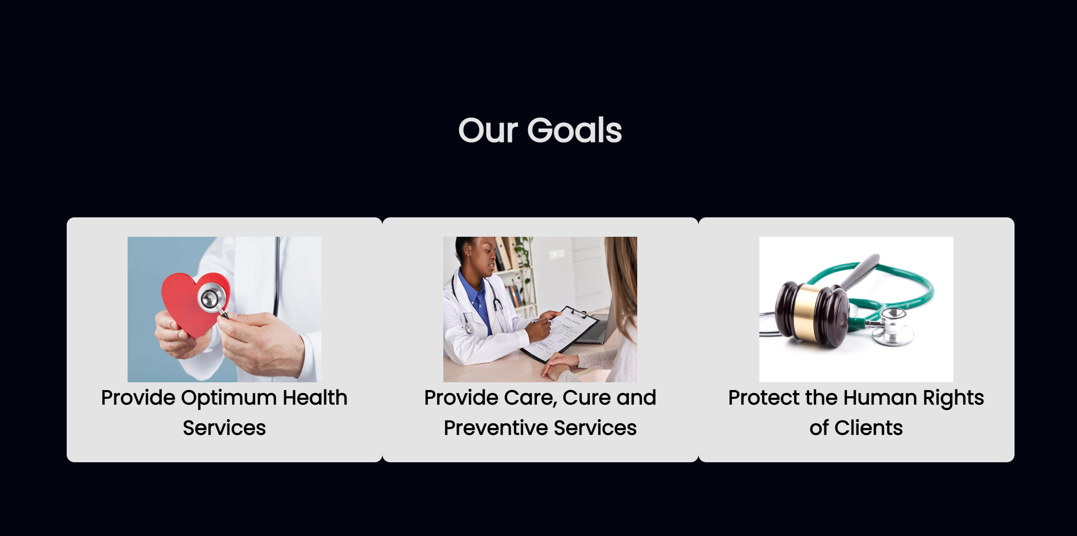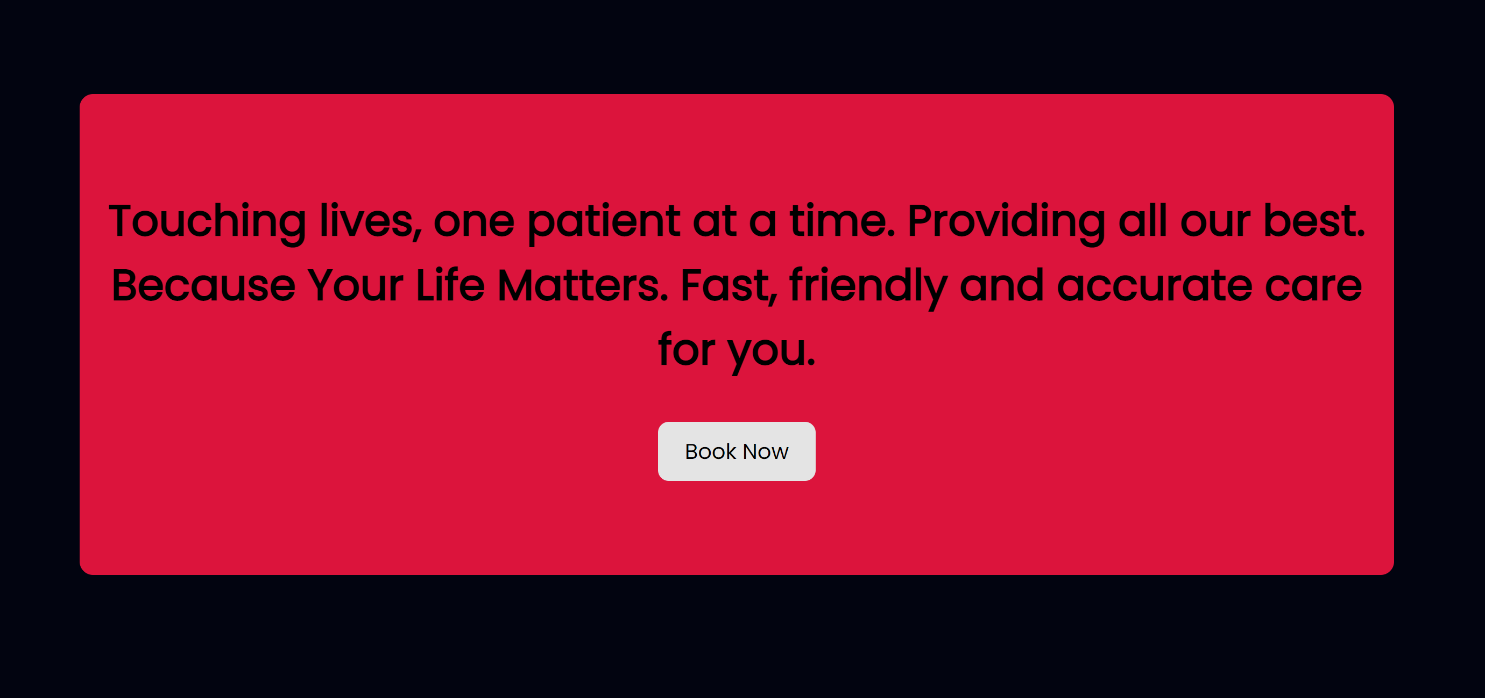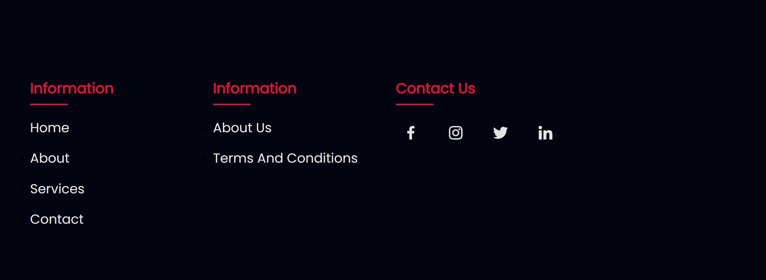

Figure 9: Home Page

### HTML

This page was simply divided into multiple div tags and multiple containers.

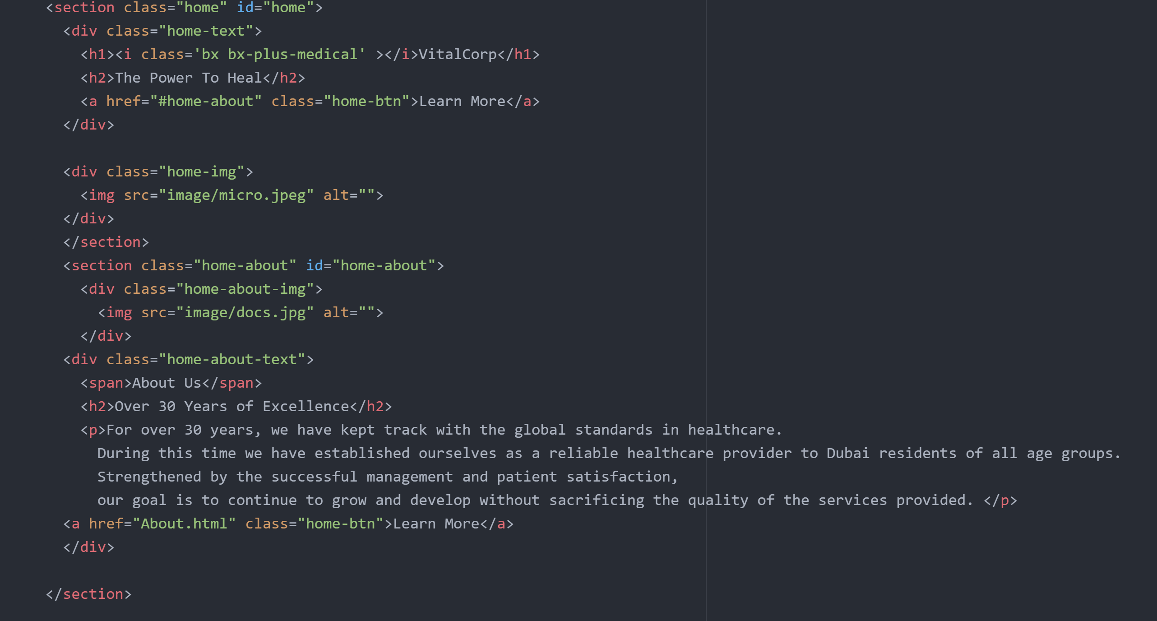

Figure 10: Partial HTML Code

### CSS

Sample of the CSS Code 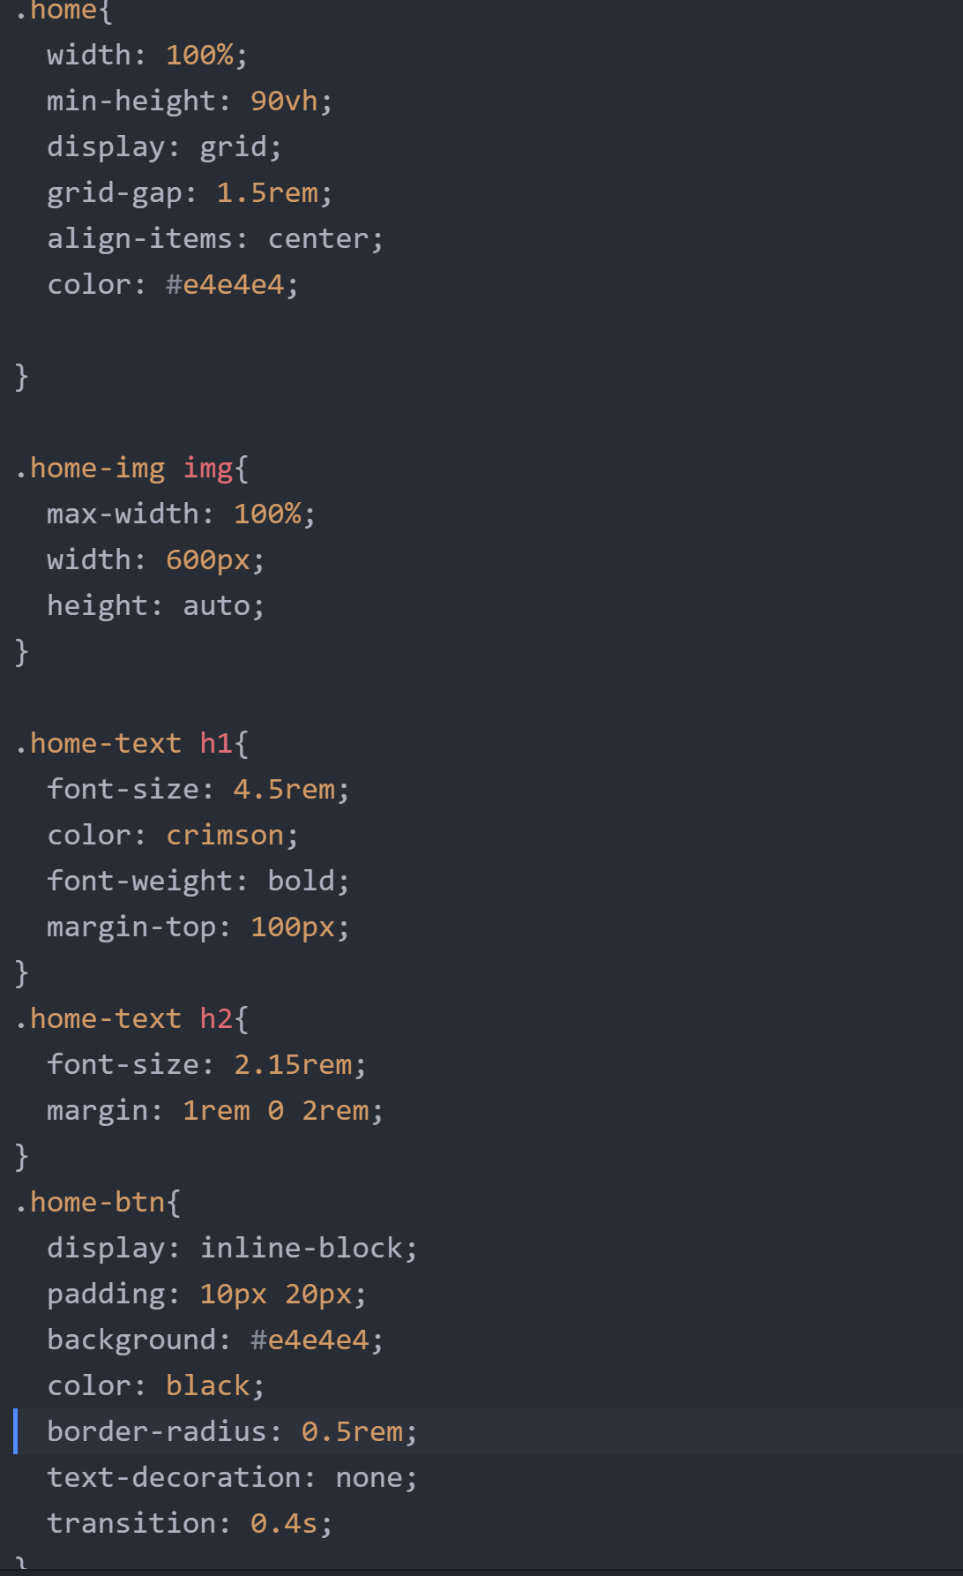

Figure 11: CSS Sample Code for Home Page

## Contact Page

This page is accessible through the footer section of the home page. 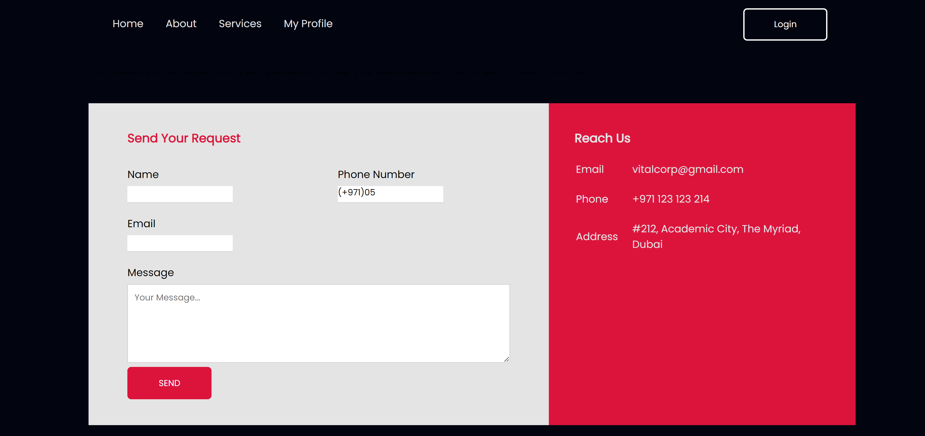

Figure 12: Contact Page

### HTML

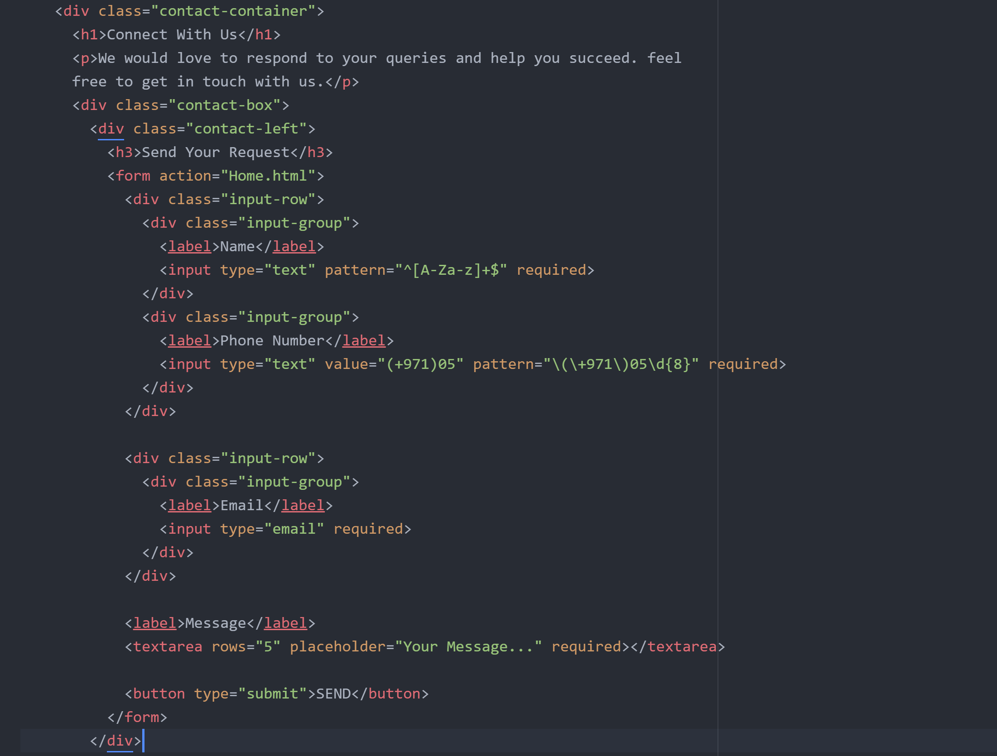

Figure 13: HTML Code of the Contact Form

The page is a simple form, with the necessary form validation, that is divided into containers

### CSS

Sample of the CSS file: 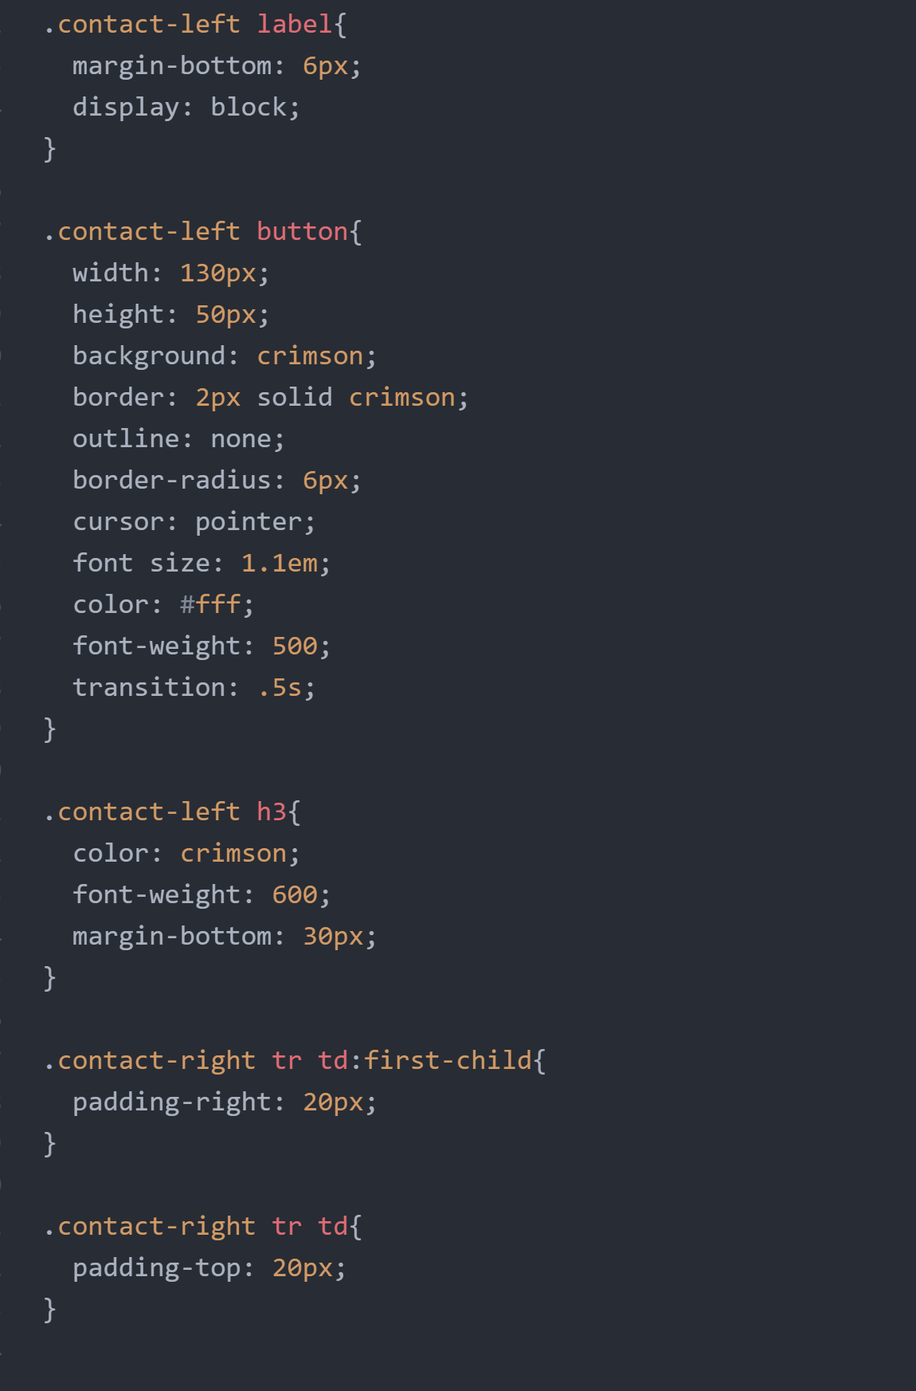

Figure 14: Partial CSS Code for Contact

## About Page

This page is accessible through the Navigation Bar.



Figure 15: About Us Page

### HTML

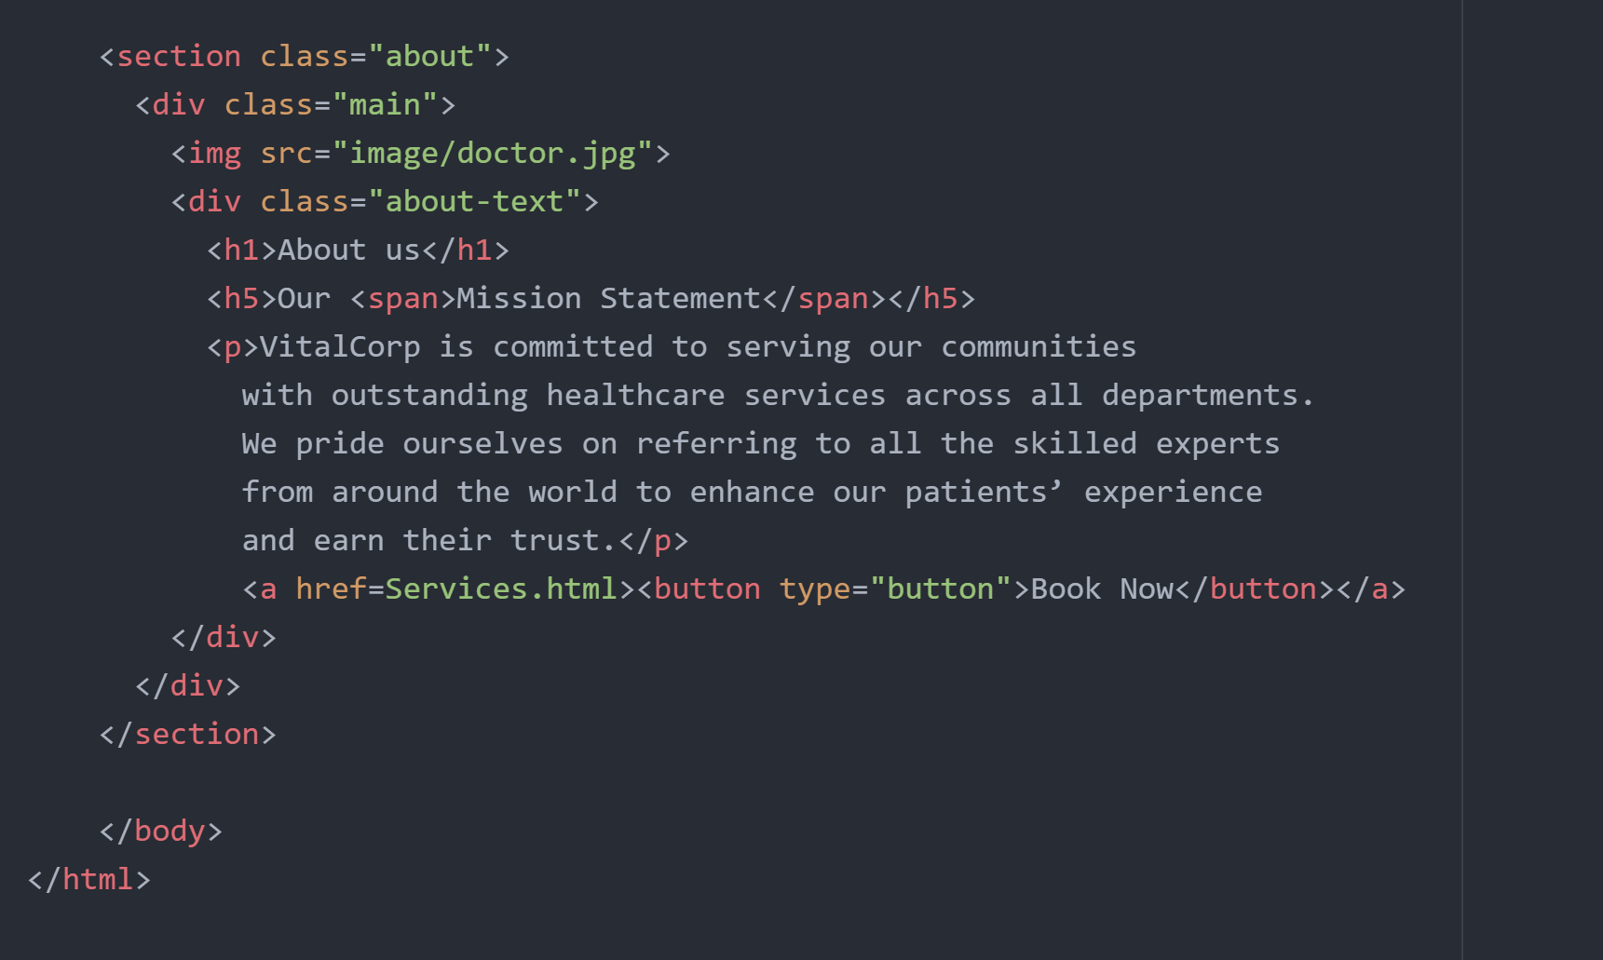

Figure 16: HTML Code for About Us Page

### CSS

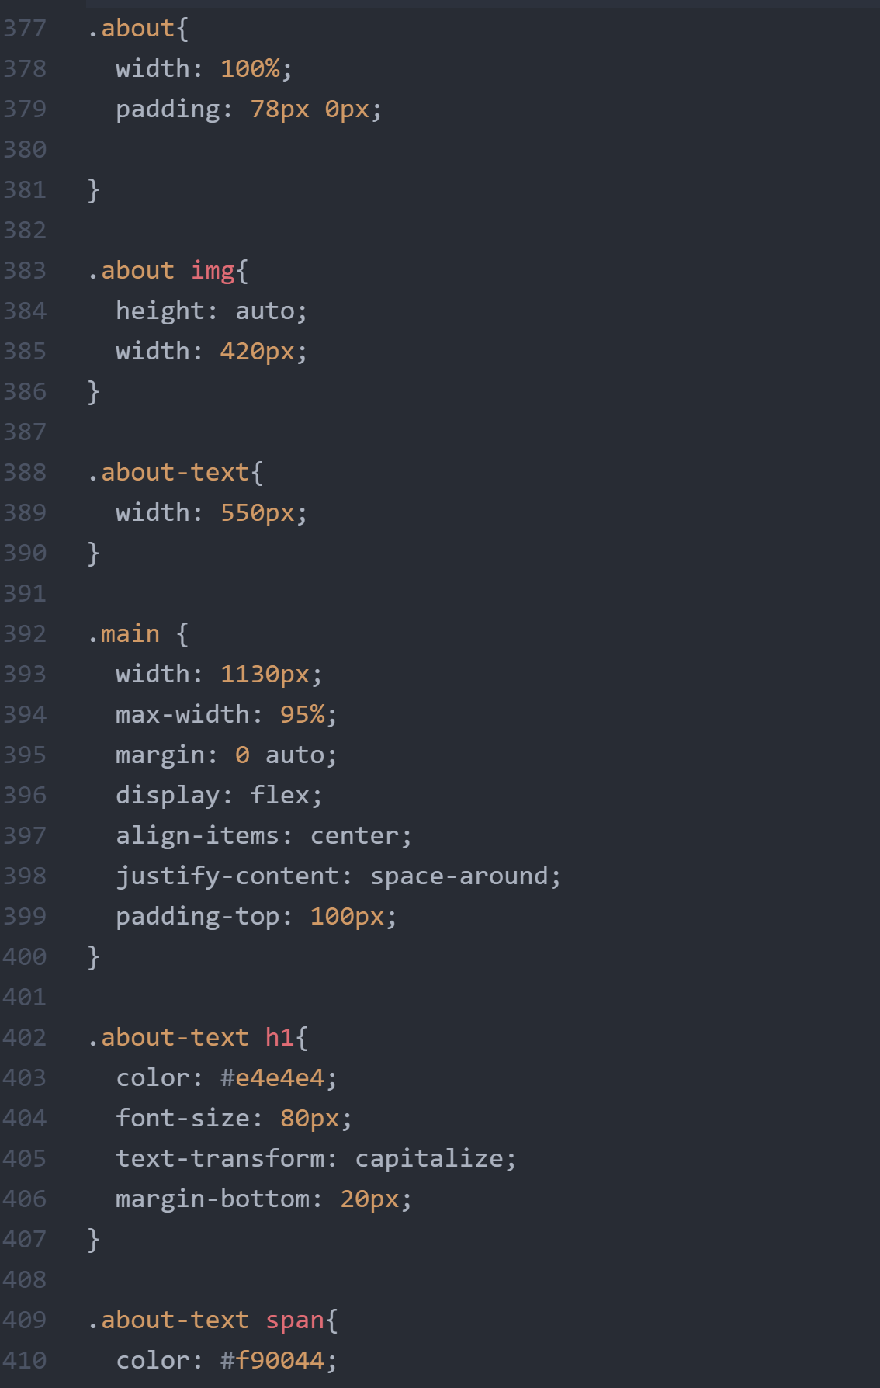

Figure 17: CSS Code for the About page

## Profile Page

This page is accessible through the navigation bar, and it’s purpose is to display the user’s credentials, the services they signed up for and the option to log-out. 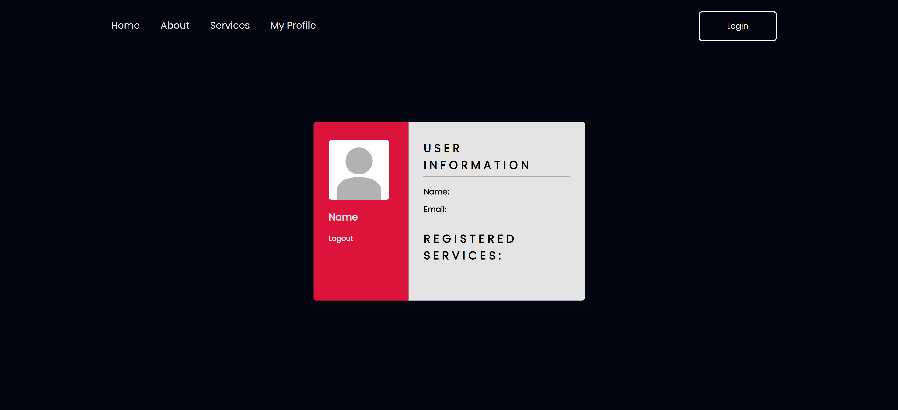

### HTML

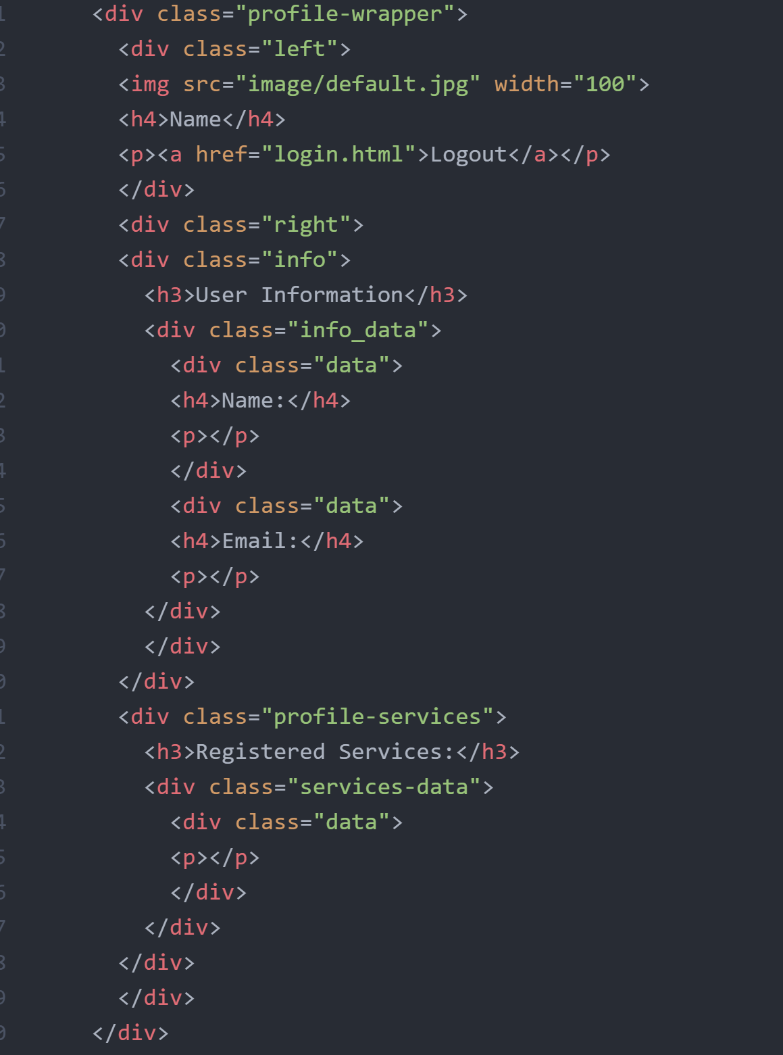

Figure 18: HTML Code for the profile page

### CSS

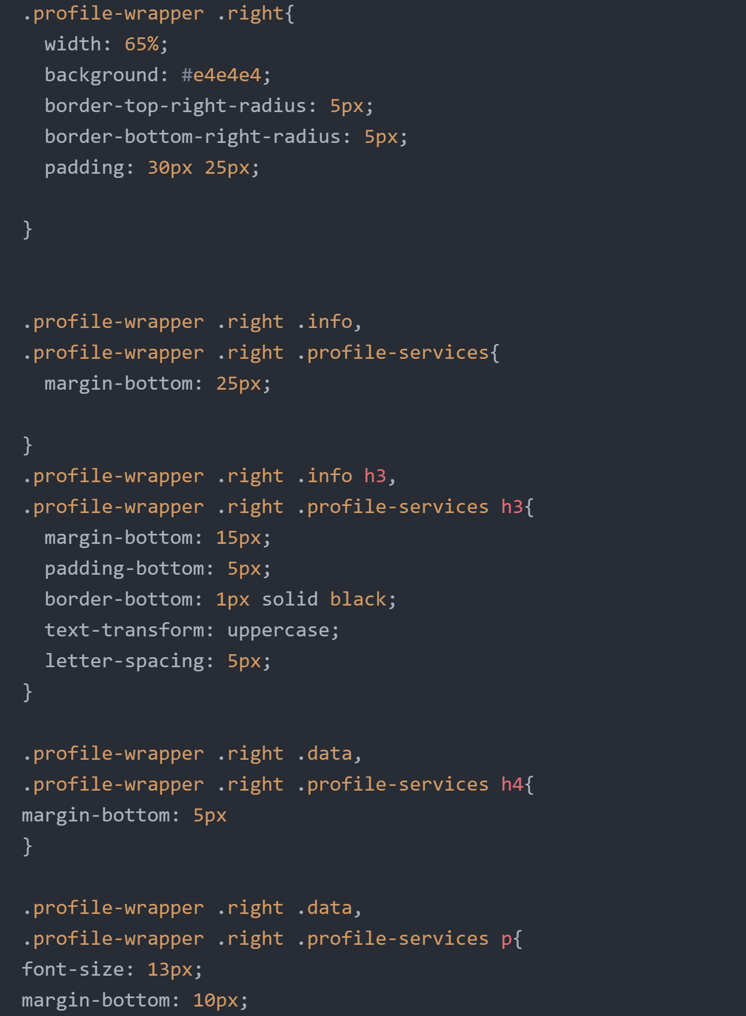

Figure 19: Sample CSS Code of the profile page

## Services.

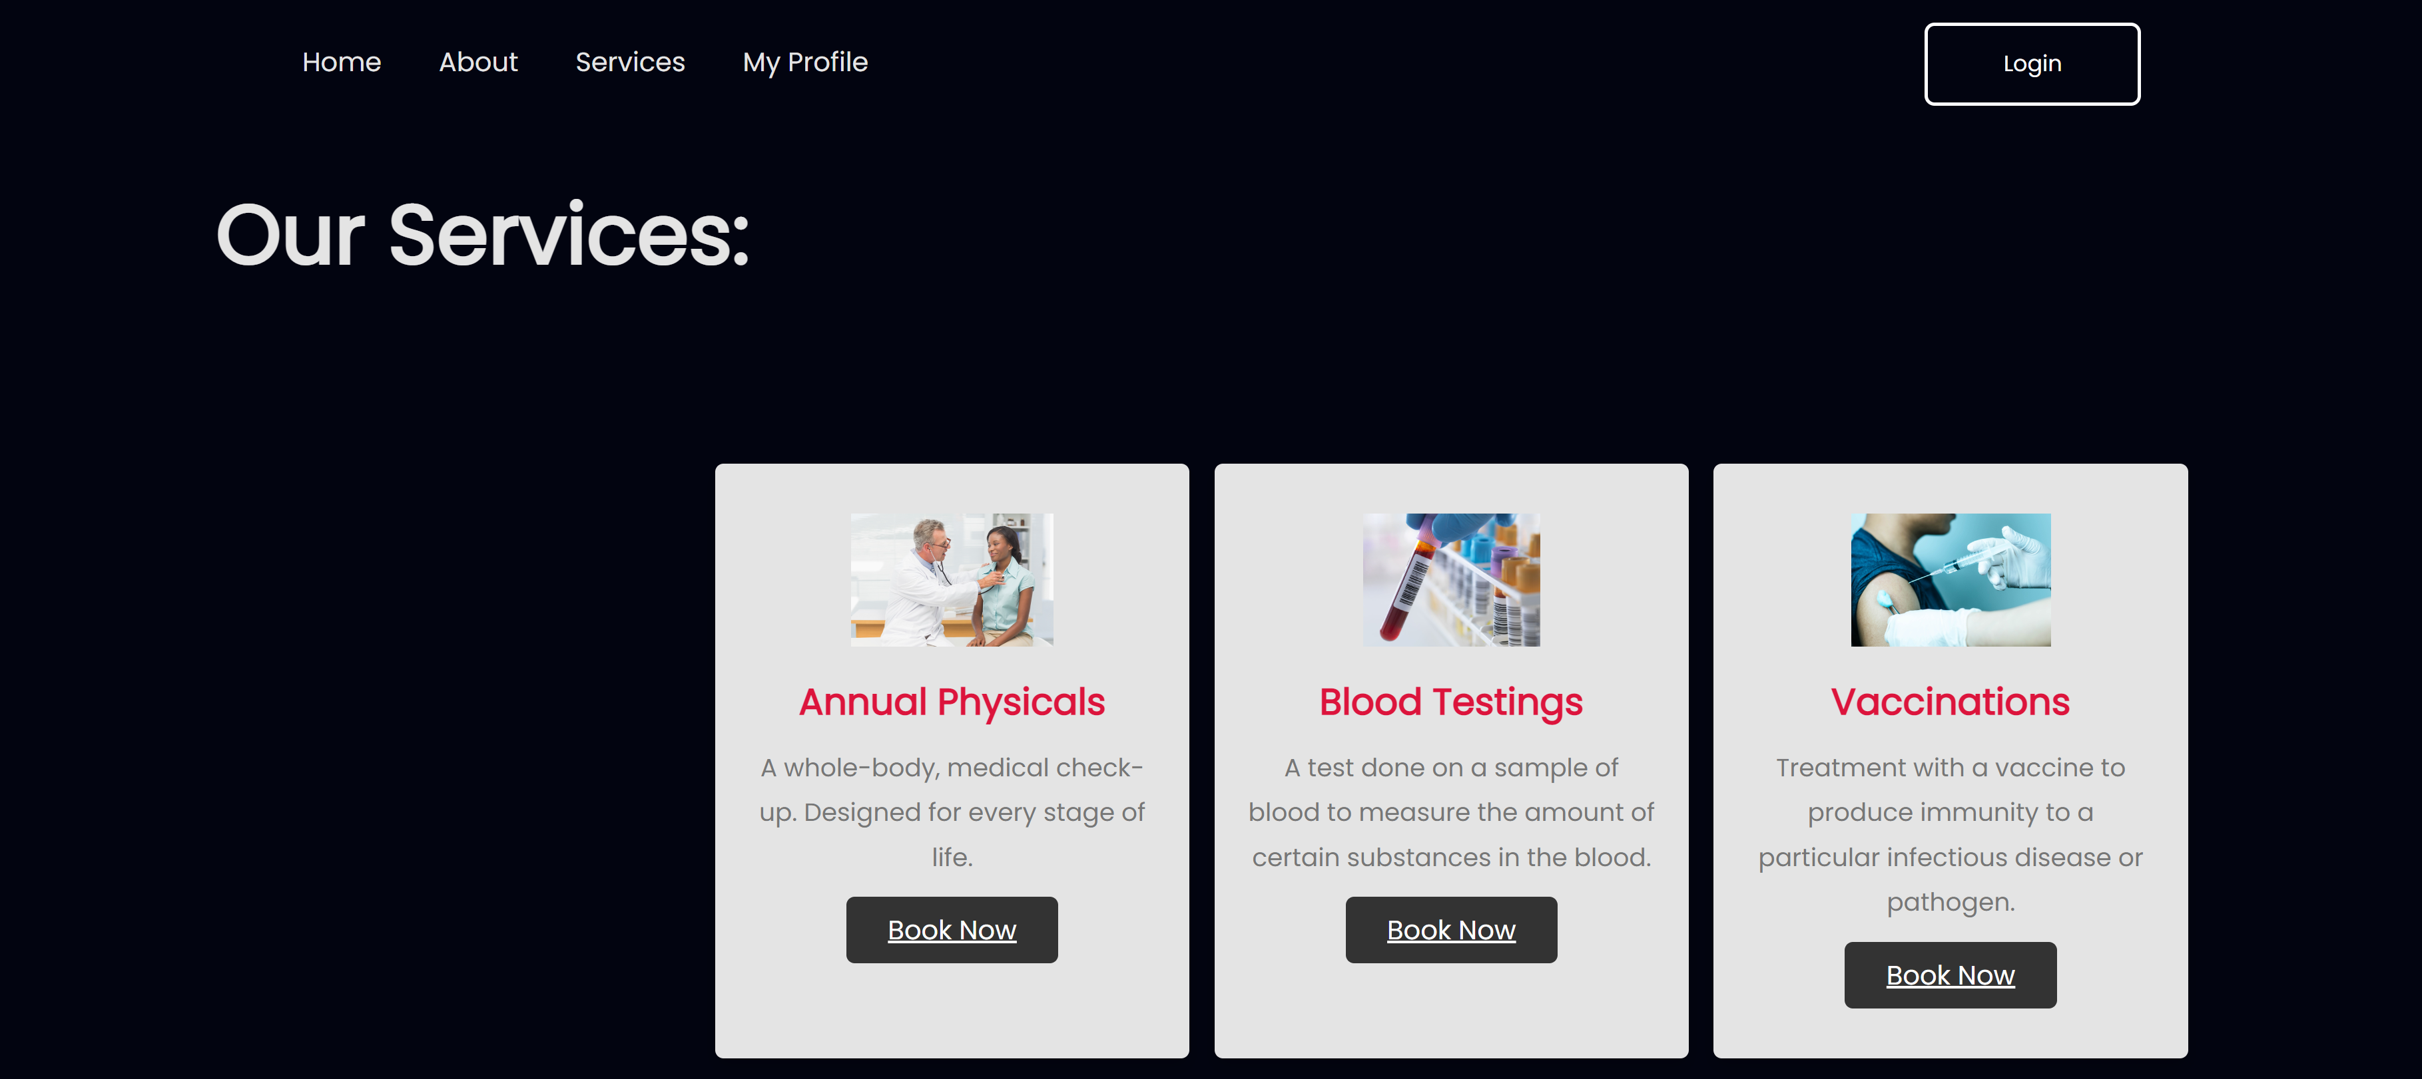

Figure 20: The Service Page

### HTML

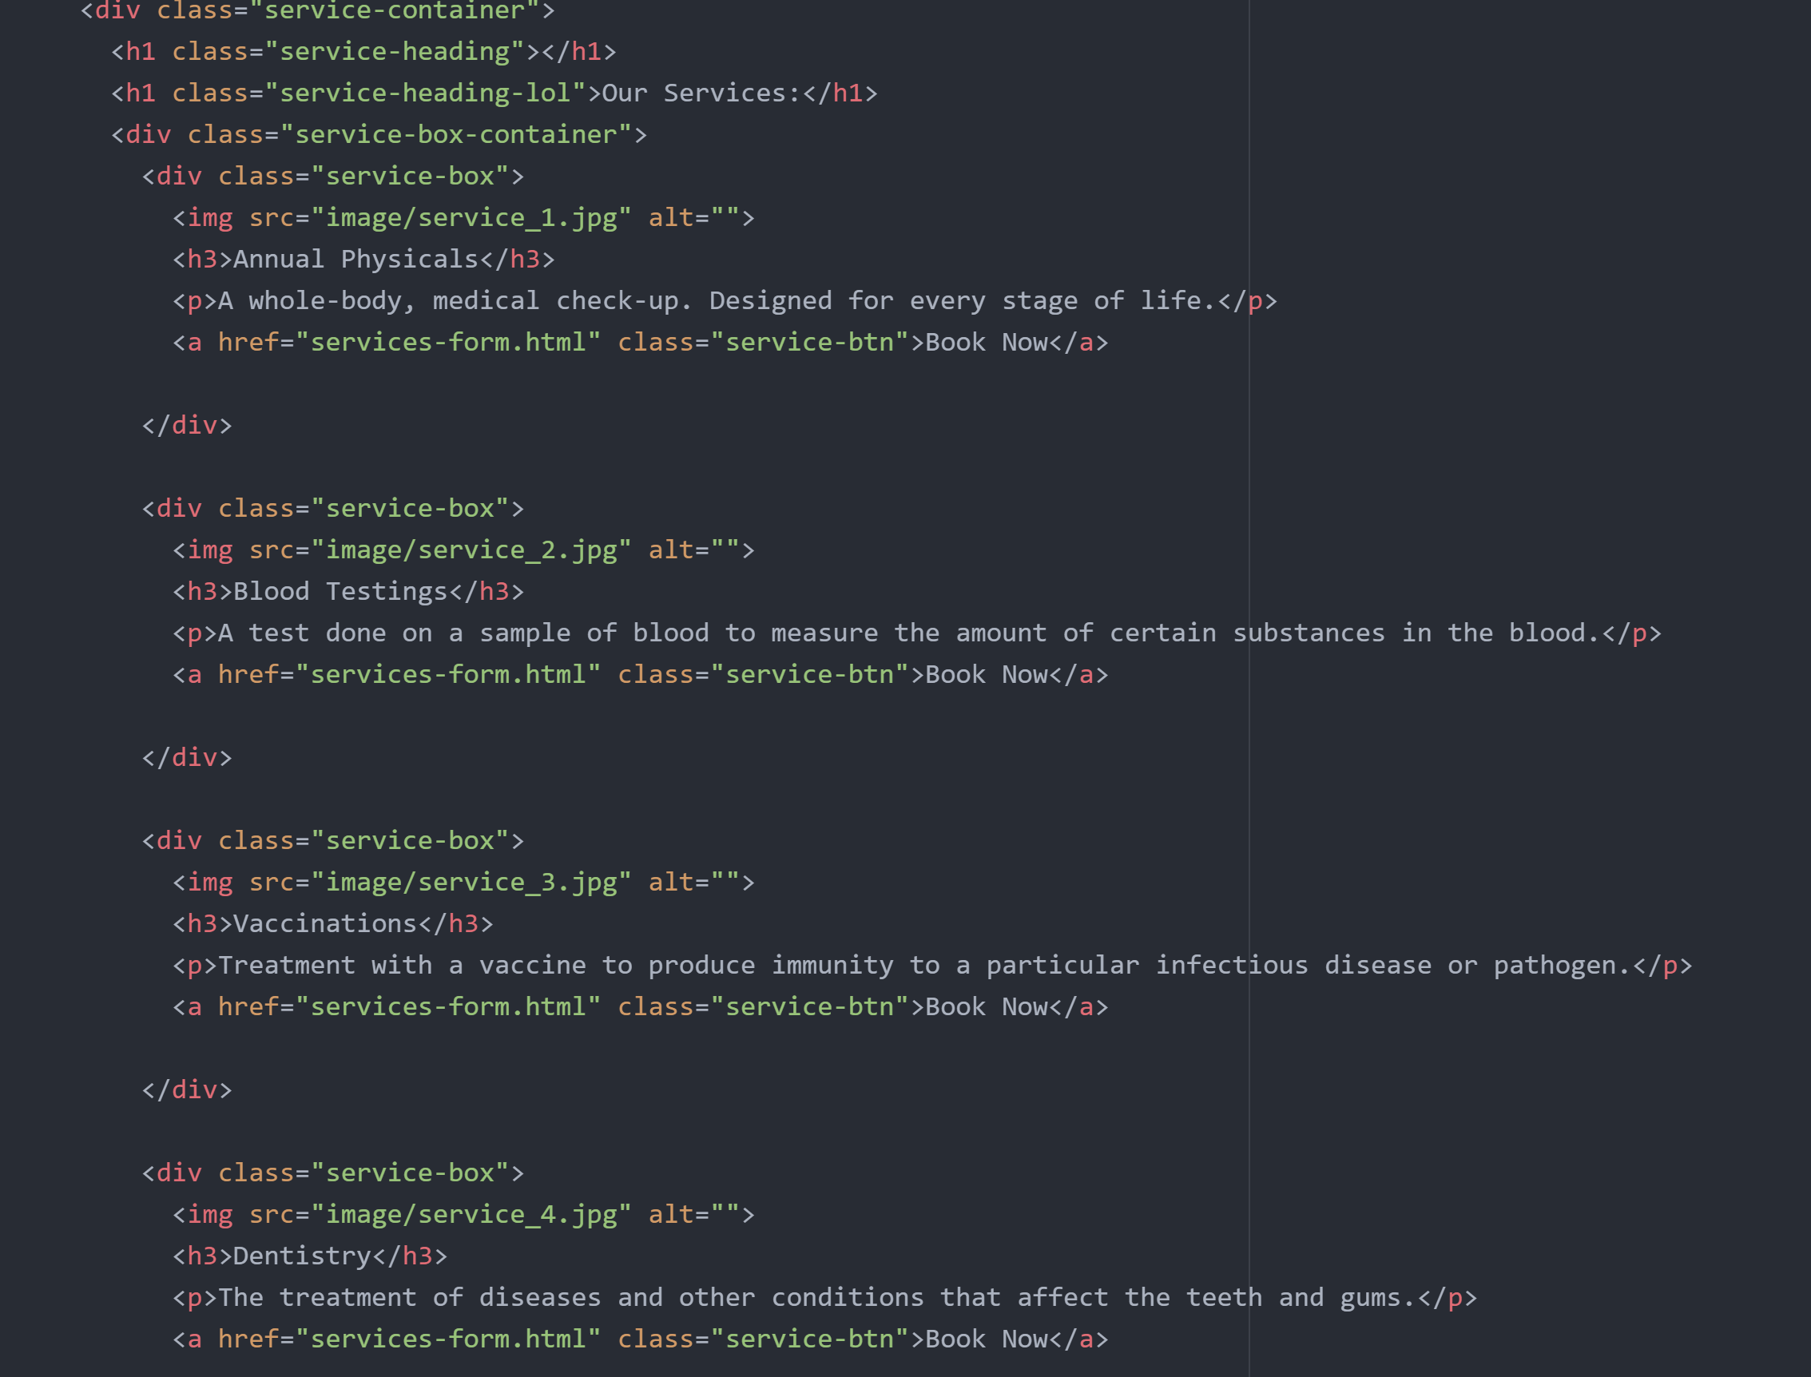

Figure 21: Simple HTML Code for the Service page

### CSS

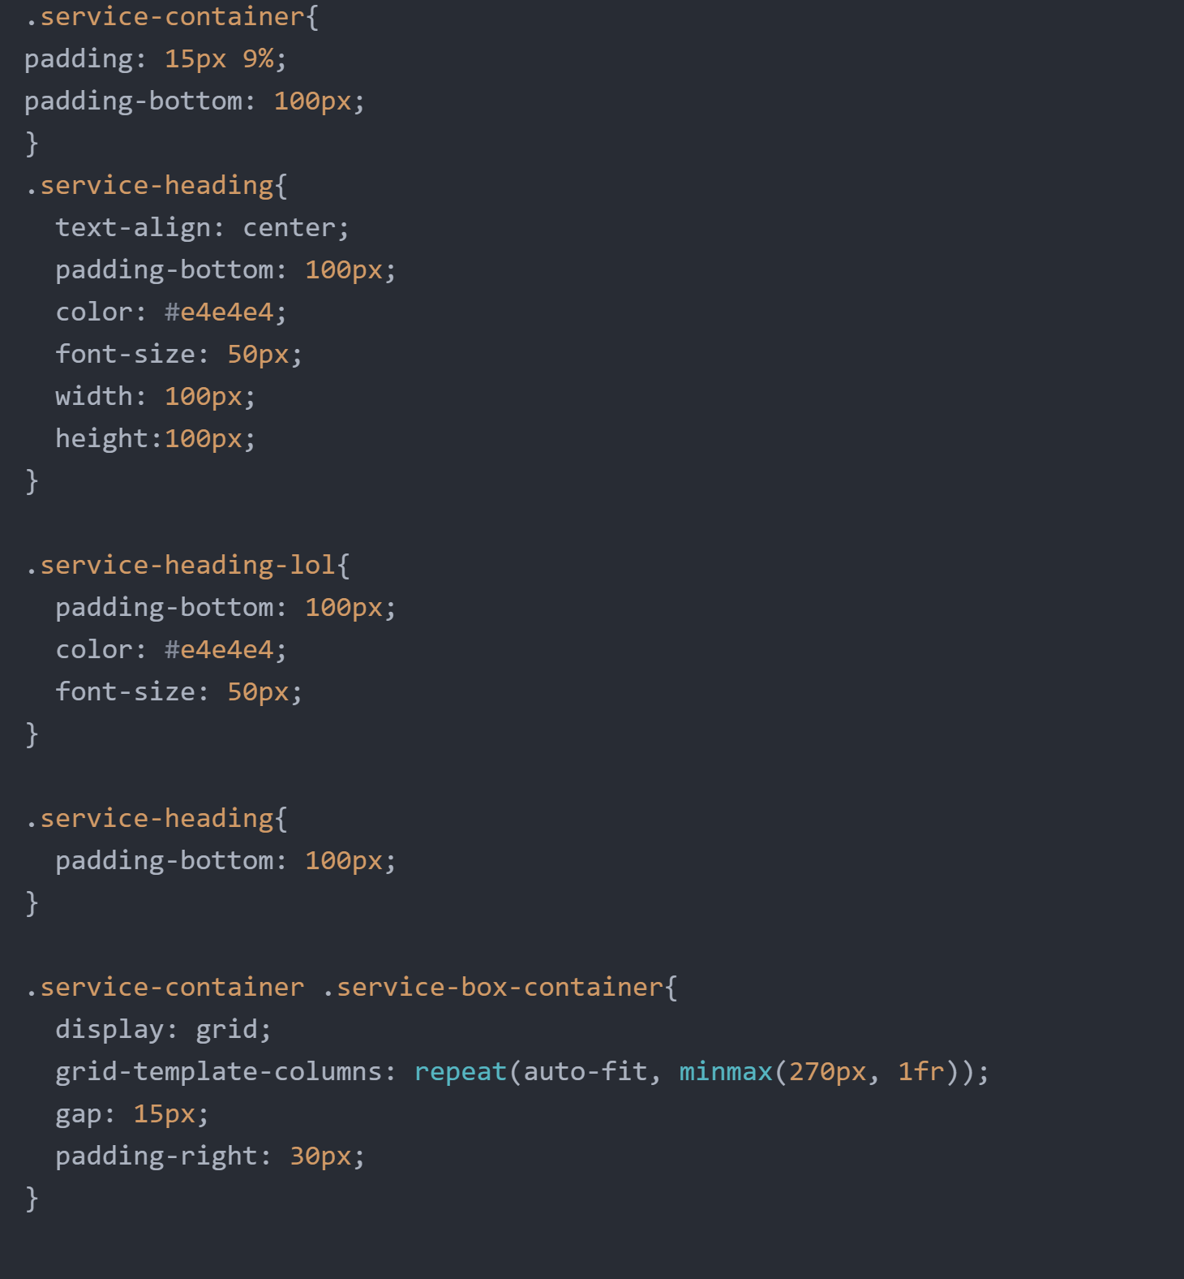

Figure 22: CSS Sample Code for Service Page

## Service Form

This page is accessible through the clicking the “Book Now” button available on the service page, where the user chooses a specific service on a date and time, with an assigned doctor.

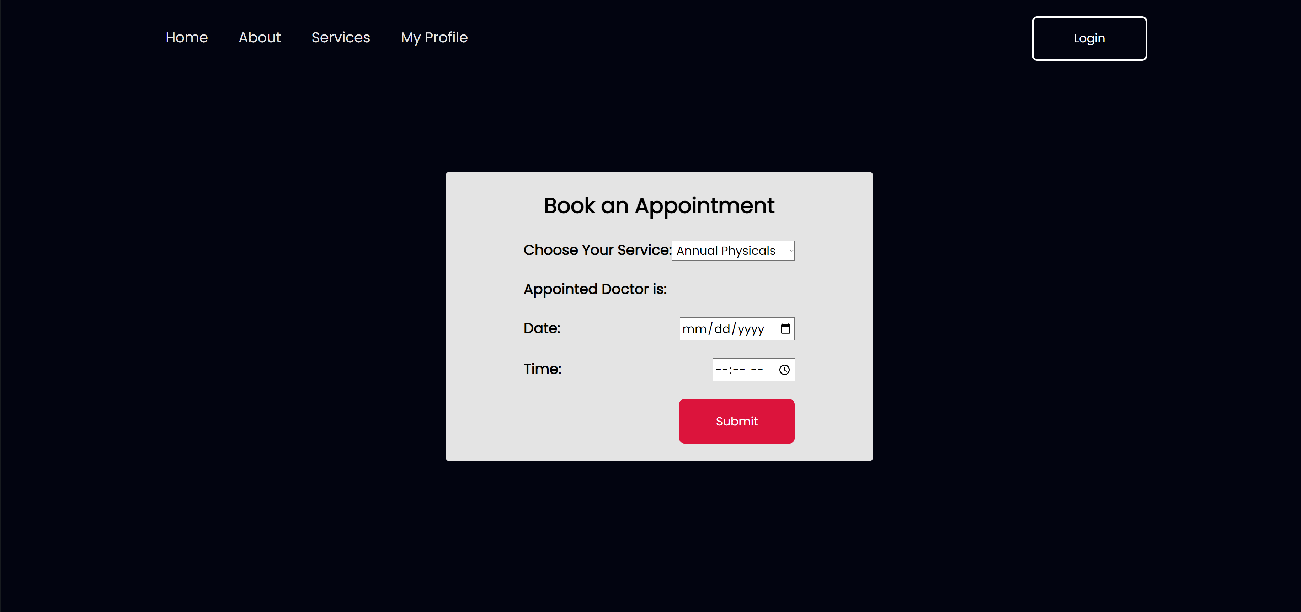

Figure 23: Service-form Page

### HTML

Simple form. 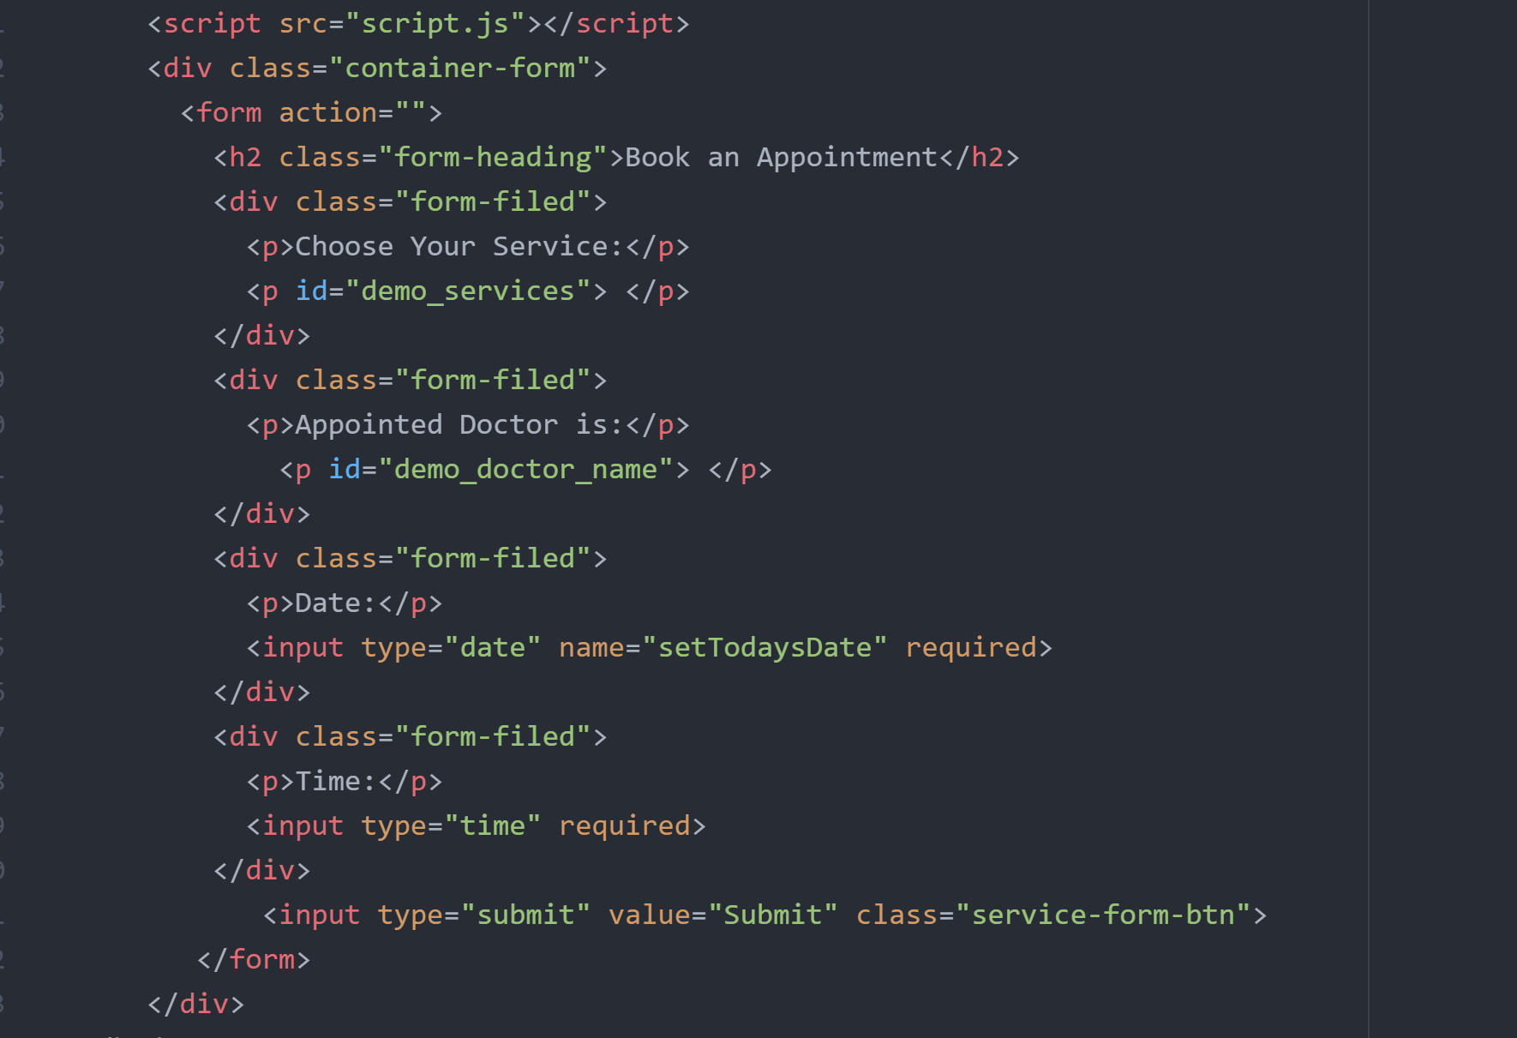

Figure 24: Sample HTML Code

### CSS

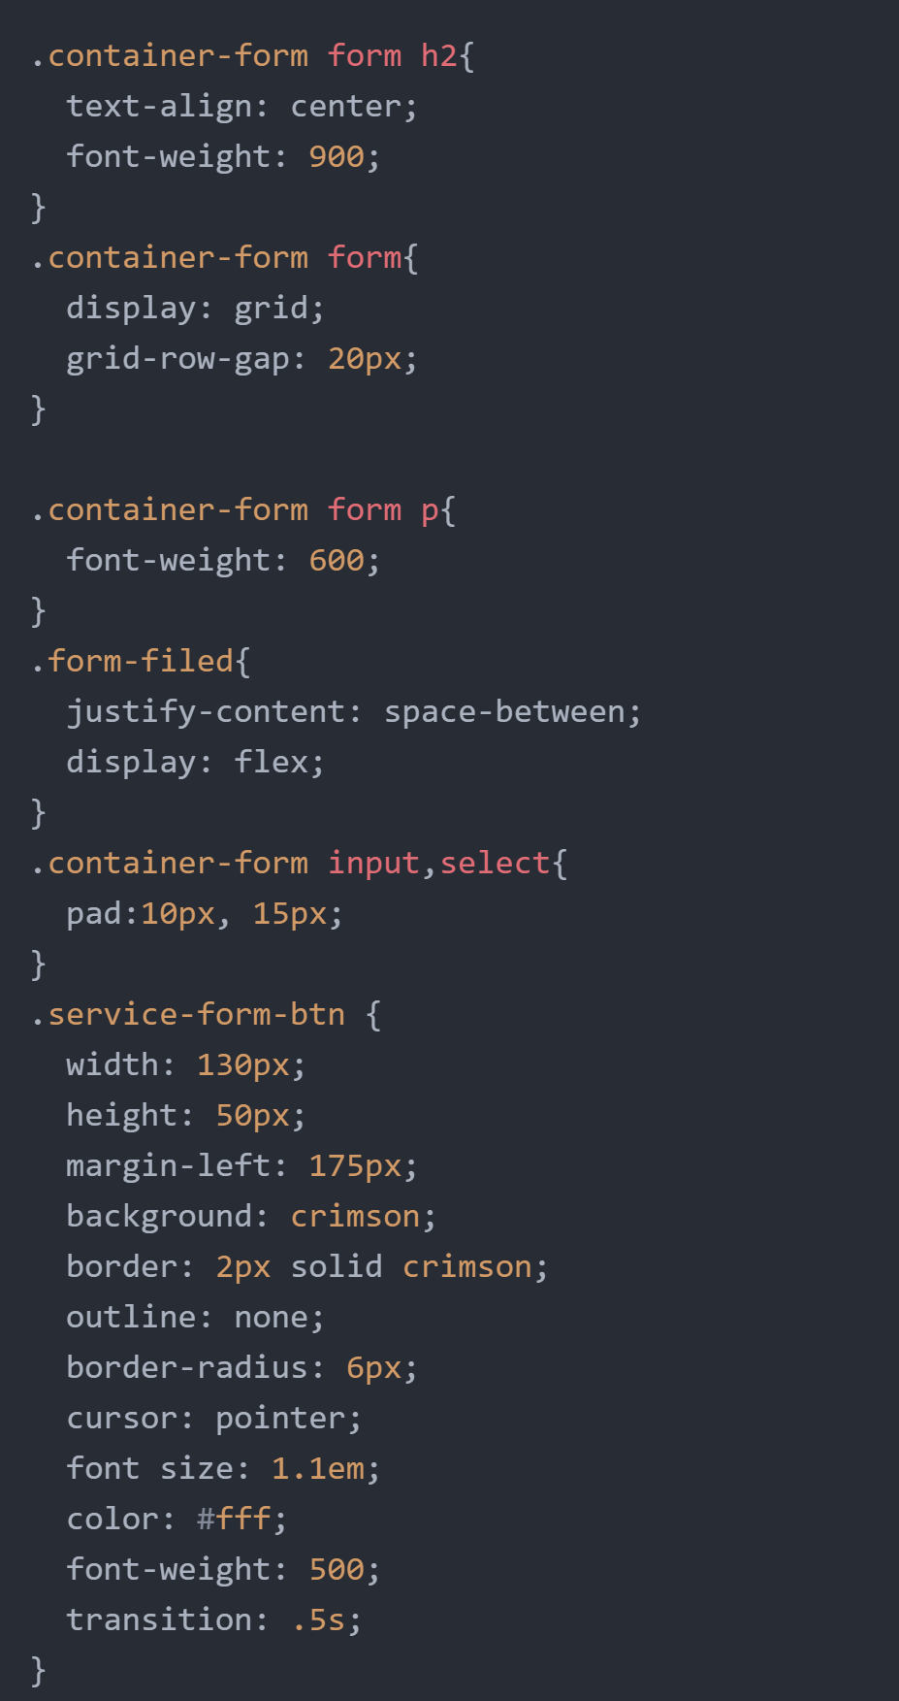

Figure 25: Partial CSS Code for the service-form page

### JSON Object

We Created a Json object to display a droplist menu of the services provided, which includes also the doctors assigned to each service.

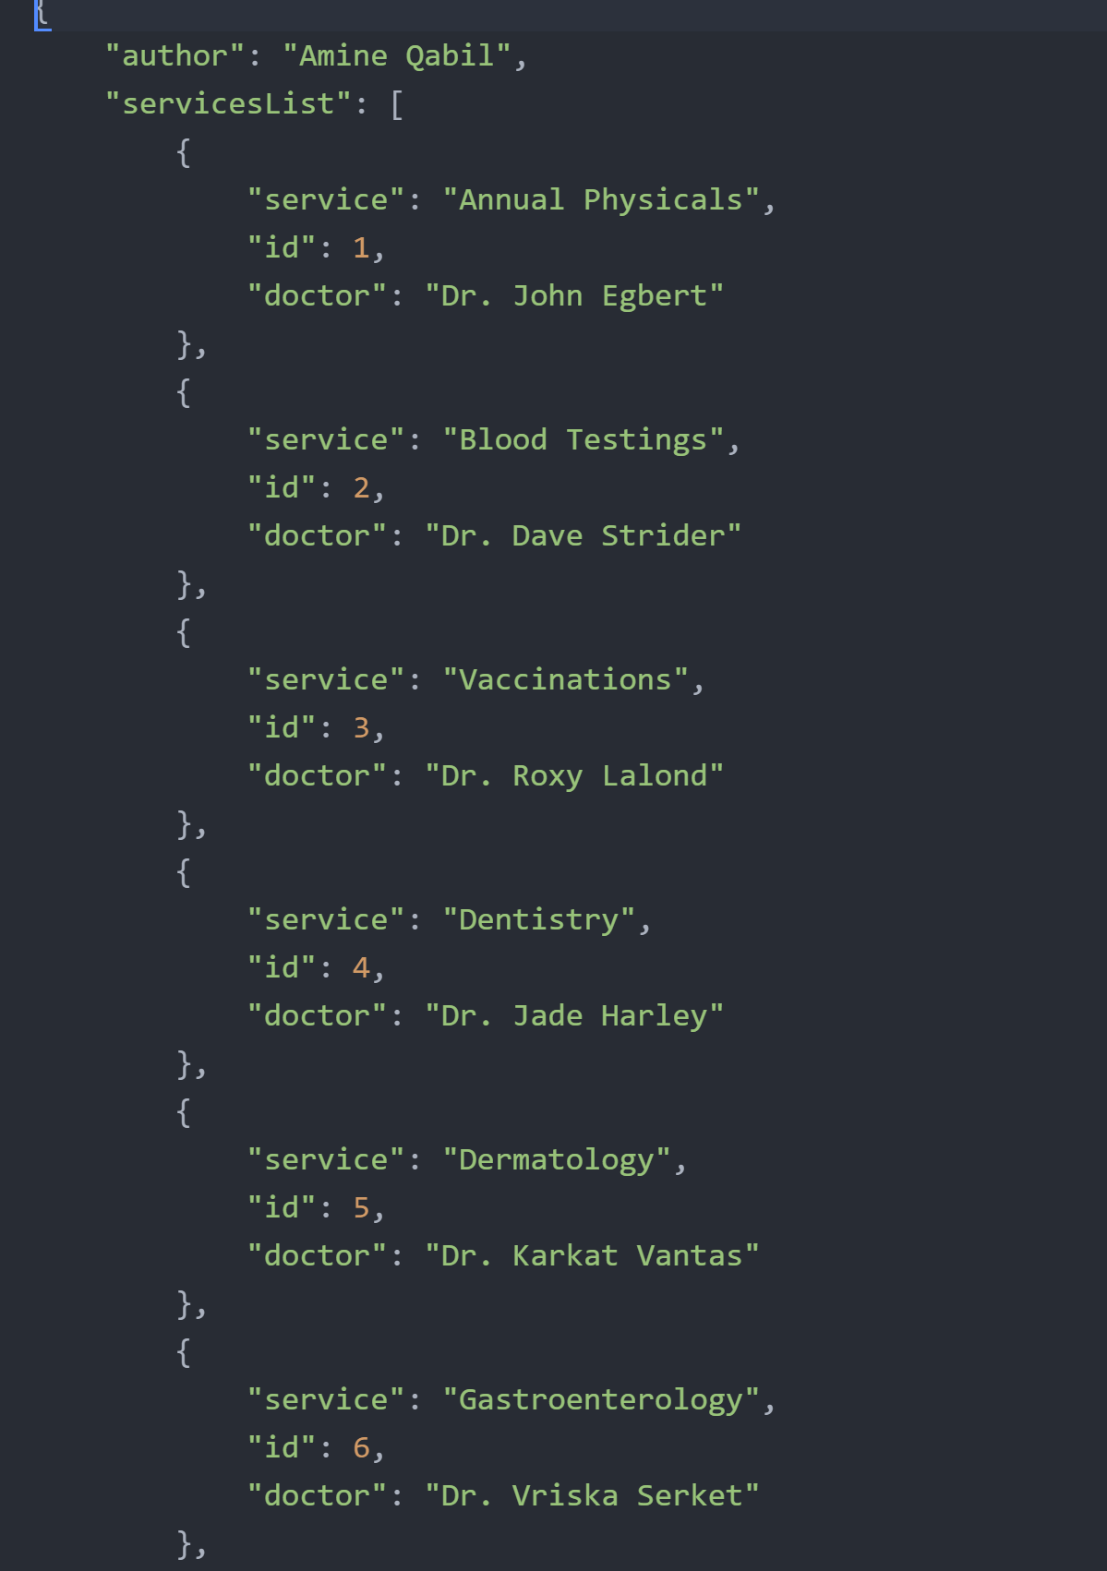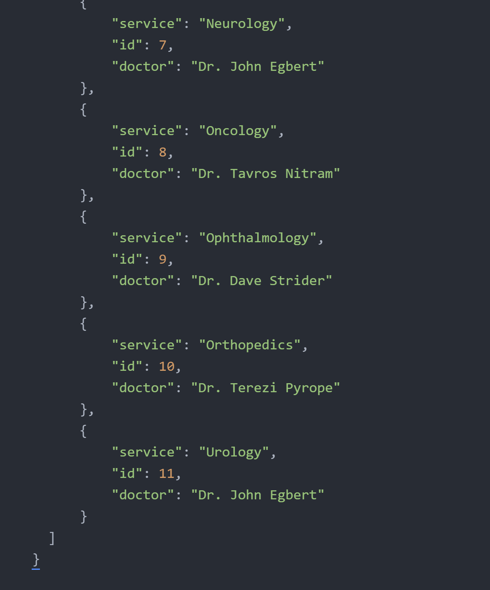

Figure 26: JSON Object

### JavaScript File

The JS file is used to process the json object.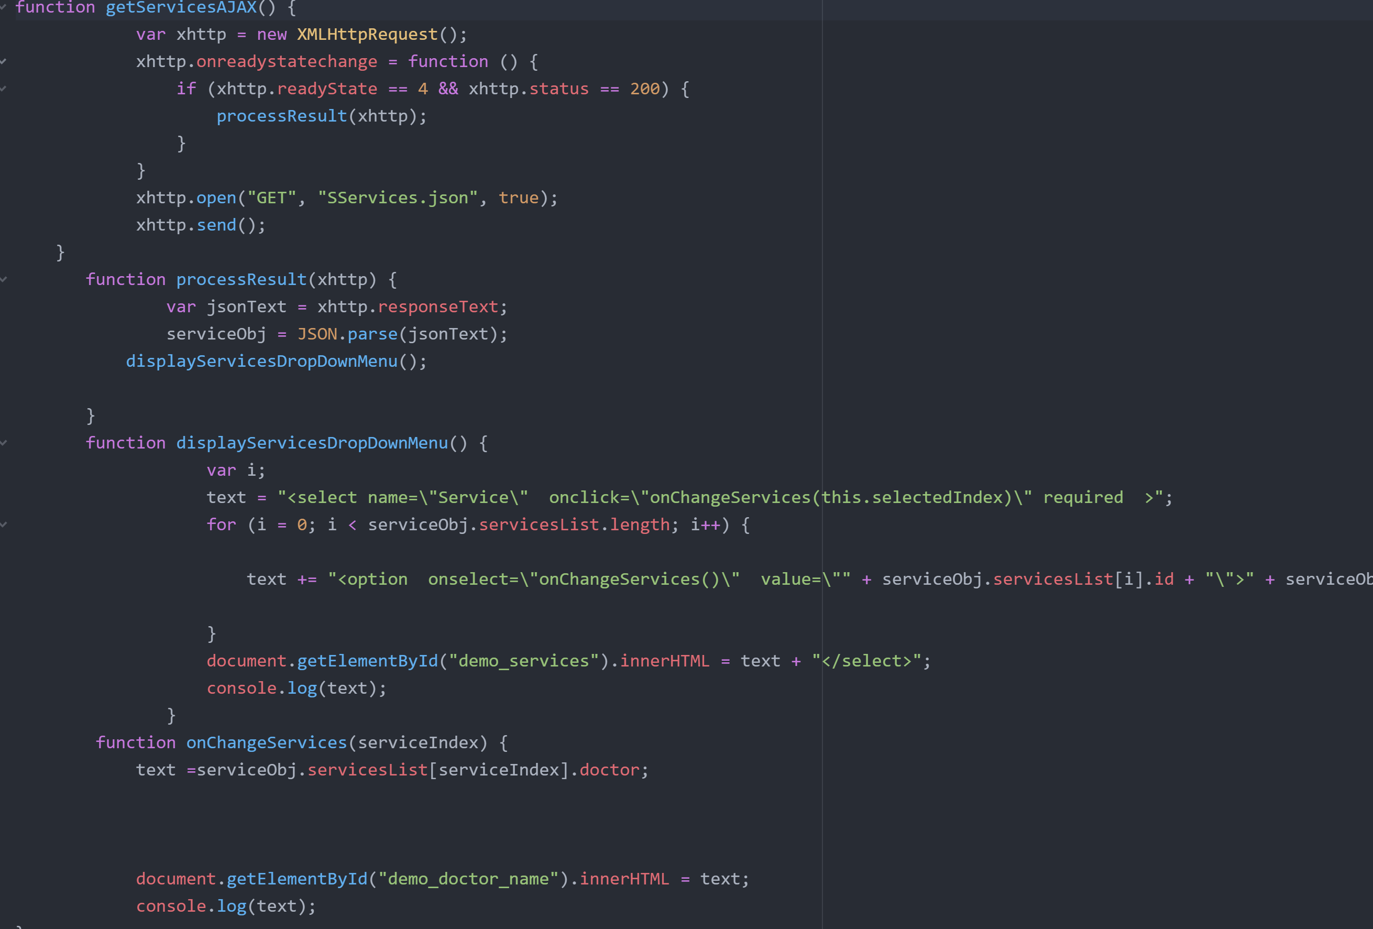

Figure 27: JavaScript Code

# Resources Used:

[**https://www.w3schools.com/html/**](https://www.w3schools.com/html/)

[**https://www.w3schools.com/css/**](https://www.w3schools.com/css/)

[**https://www.w3schools.com/js/**](https://www.w3schools.com/js/)

[**http://stock.adobe.com**](http://stock.adobe.com)

[**https://boxicons.com/?query=**](https://boxicons.com/?query=)